

The Guiding Reference Framework
for Higher Education in the Arab Republic of Egypt
Ministry of Higher Education
Supreme Council of Universities

2025
Table of Contents
Introduction 1
1. General Framework 2
1.1. Why do we need a guiding reference framework to develop academic programs? 2
1.2. The guiding reference framework philosophy for designing study programs 3
1.3. Layout of academic program design 4
1.4. Rules of academic frame of reference 18
1.5. Frame of reference determinants of academic regulations at the B.A./B.Sc. level 20
1.6. Technological Higher Education Track 26
1.7. Entities Supporting Teaching and Learning Processes 29
1.8. Adopting Artificial Intelligence (AI) tools as a catalyst of change in learning methods and scientific research 29
2. Requirements For Science Fields 32
2.1. Arts & Humanities 32
2.2. Social Sciences 33
2.3. Life Sciences & Medicine 34
2.4. Natural Science – Engineering & Technology 35
Annexes 37
Annex (1) 38
Annex (2) 40
Annex (3) 41
Annex (4) 44
Annex (5) 46
Annex (6) 50
Annex (7) 51
Annex (8) 54

Table of Figures
Figure 1: The Guiding Reference Framework Philosophy for Designing Study Programs. 3
Figure 2: Layout of Academic Program Design. 5
Figure 3: Block-based Course System 5
Figure 4: Roles of Advisory Board at B.A. and Postgrad Levels. 7
Figure 5: 17 Global Goals for Sustainable Development. 8
Figure 6: An example illustrating the concept of integrated academic stages within a single academic program. 9
Figure 7: A strategy for designing academic programs in the form of integrated stages that support pathway diversity and reinforce the concept of differentiation and uniqueness. 10
Figure 8: Scientific Research Course and the Reciprocal Relationship Between Undergraduates and Graduates. 12
Figure 9: An example illustrating the concept of a project-based professional academic training program (Thread). 14
Figure 10: Selected Topics Courses and Their Potential Integration with Professional Academic Training Programs (Thread). 15
Figure 11: A diagram illustrating the concept of having a defined yet flexible study plan. 16
Figure 12: Benefits of Specific and Flexible Academic Plan. 16
Figure 13: The Relationship between Academic and Technological Higher Education Pathway. 27
Figure 14: A diagram illustrating the relationship between awarded degrees and competencies in the engineering sector for instance. 29

Table of Tables
Table 1: Matrix of the Relationship between the principles of the Higher Education Strategy 2030 and the academic program design layout. 17
Table 2: Classification of Graduate Prerequisites. 20
Table 3: Distribution of Program Hours on Graduate Prerequisites. 21
Table 4: Course marks and grades and the number of equivalent points. 23
Table 5: Comparison between Academic and Technological Higher Education Pathways. 27

Introduction
The “Future Jobs Survey 2023” report issued by the World Economic Forum affirms the fast transformation of the labor market due to the acceleration of technological advancement and economic turns. Emerging fields, such as AI and data analytics, witness huge growth, leading to the decline of some jobs and emergence of others in various fields. The report stresses the urgent need for continuous training and skills development, underscoring the sustained demand for technical and soft skills. Furthermore, special focus is placed on adaptability, critical thinking, and problem-solving abilities. Automation and artificial intelligence equally pose challenges and offer opportunities, necessitating strategic policies to manage the labor market shifts. Additionally, the report asserts the crucial role of diversity and inclusivity in enhancing innovation and entrepreneurship.
This aligns with modern studies which indicate that the student-centered educational approach, based on the idea of building knowledge through positive student interaction in educational experiments “as active participants”, guarantees a dynamic educational process and its continued growth, fostering the value of “Lifelong Learning Skills”. The impacts of this approach have been reflected in the development of higher education in successive university generations. The first generation witnessed the traditional mode, where theoretical learning depended on traditional lectures and libraries. The second generation witnessed an expansion in scientific and technological disciplines, followed by the third generation, with integration in society and the shift to practical learning and training. Finally, the fourth-generation universities adopted modern technology, placing emphasis on the necessity of developing critical thinking and innovation skills, and adoption of flexible distance learning models.
In this context, it must be noted that those currently enrolled in higher education belong to Gen Z, generally called the "Zoomers". The "Zoomers" will remain for the next five years, succeeded by the Gen Alpha. Despite differences between the two generations, they share the growth experience in the digital era. Gen Z grew up in the age of the internet and smart phones, where technology has been and is still a vital part of their life and learning process. Gen Alpha, contrariwise, is the first generation to fully grow up in the twenty first century and to witness rapid technological advances, on top of which is artificial intelligence. Accordingly, technology integration into their learning experiences must be enhanced. The two generations, in their social interaction field, rely on social media and digital communication. With the continuous development in these fields, Gen Alpha may exhibit enhanced social interaction skills that should be taken into consideration in the teaching and learning process. This was stressed by the "Future of Jobs Survey 2023" report, indicating the importance of social skills and their relevant jobs that witness significant transformation. Hence, the importance of applying social norms in various business areas becomes evident. It is also highly important to develop curricula to meet the needs of advanced technology; meanwhile, the challenges in social and emotional aspects must be addressed. Both generations manifest social media addiction, requiring specific emphasis on appropriate usage of technology to align with the nature of the two generations.
In this regard, this framework offers a vision and a general framework that supports and guides the design of academic programs to ensure sustainable development of the quality of higher education or even pre-university education. It is a process that requires concerted efforts, where flexible content quality and methodology unite with the quality of the educational environment and the competence of the educator as a mentor towards an "active" and "creative” student. This orientation of the fourth-generation universities is expected to constantly stress active learning, as well as critical and creative thinking skills.

1. General Framework
In this section, the proposed general framework for development of the academic programs will be discussed, comprising the following items detailed later:
- Why do we need a guiding reference framework to develop academic programs?
- The guiding reference framework philosophy for designing study programs.
- Layout of academic program design.
- Rules of the study frame of reference.
- Determinants of the frame of reference for academic bylaws at the B.A./ B.Sc. stage.
- The pathway of higher technological education.
- Entities sponsoring the teaching and learning processes.
- Adoption of AI tools as a catalyst for change in learning methods and scientific research.
  - Why do we need a guiding reference framework to develop academic programs?
Based on the above, the development of academic programs in higher education requires a general frame of reference to ensure guidance and consistency. This enhances the "equitable" learning experience for students across various disciplines and academic levels and realizes the concept of "academic excellence" in university education. The analytical study of the gap between the current frames of reference and reference guides of the committees of university education sector at the Supreme Council of Universities manifest lack of many necessary elements (Annex 1). Hence, the unified framework seeks to:
- Determine the general philosophy, objectives and values that form the essence of academic program design, while focusing on diversity and educational equity.
- Determine general standards for academic program preparation at higher education institutions to form its clear and defined outline.
- Guide the procedures of academic bylaws’ design and formulation to align with the latest frames of reference issued by the relevant sector committee and in a way that complies with the most universally recognized study systems to boost the employability of the graduates of Egyptian universities in regional and international labor markets and to facilitate the mobility of students across higher education institutions worldwide.
This framework also considers all requirements of every field of science in higher education, including arts, humanities, social sciences, life sciences and medicine, natural sciences, engineering and technology (Annex 2).
  - The guiding reference framework philosophy for designing study programs
Educational philosophy differs across the world with the differing historical, cultural, and regional aspects. However, there are some common topics and theses about higher education universally, which are important to be taken into consideration. It is to be noted that higher education philosophy is dynamic, reflecting changes in social values, technological advancement and scientific research. Nevertheless, it is crucial that the general frame of reference embraces a philosophy, representing the basic vision and values guiding the process of designing academic programs in higher education institutions. This philosophy is also crucial to reflect the key objective of education, namely, qualifying students and developing their skills and knowledge. "Student-Centered Education" and "Interactive Learning" realize this objective, enhancing the values of "Lifelong Learning Skills". It is imperative that this frame of reference aligns with standards of quality and accreditation, enjoys flexibility in order to accommodate diversity and excellence, and reflects the educational institution's abilities and potentials, in both human and material aspects. Additionally, it must observe the specific standards of international accreditation bodies. Hence, to realize the value of lifelong learning, the principles of higher education and scientific research 2030 must be upheld (Figure 1):
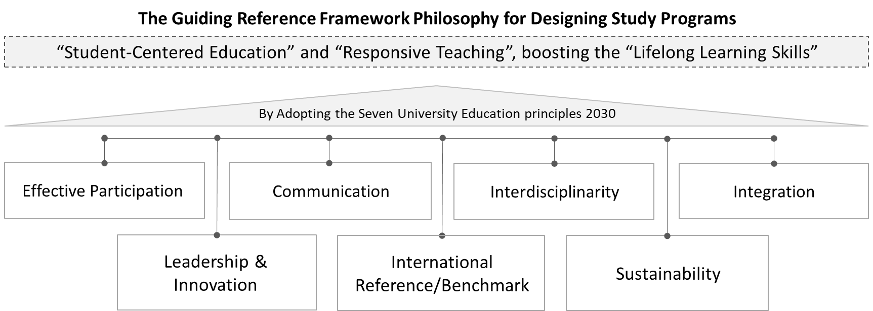
Figure 1: The Guiding Reference Framework Philosophy for Designing Study Programs.
First: Integration: In terms of development of academic programs, the term "integration" refers to the idea of linking knowledge and skills from different fields to formulate a comprehensive and integrated understanding. Additionally, integration aims to bolster interaction across various topics and offer broader perspectives for students. This interaction and integration between different disciplines can involve various academic subjects, theoretical concepts, practical application, practical experiences and the business sector.
Second: Interdisciplinarity: Interdisciplinarity endorses the development of holistic educational programs, leading to integration of fields and promotion of comprehensive thinking. Diverse disciplines result in students’ acquisition of multiple skills, and in turn enhanced qualifications to meet the business sector’s needs. This diversity also allows them to effectively apply knowledge in various contexts to strengthen their problem-solving abilities and trigger creativity and innovation.
Third: Communication: Communication is essential to enhance the structure of university programs, where communication and cooperation are integrated internally and across borders. This involves combining the local and regional elements with international elements, while focusing on promoting cultural exchange and joint scientific research. Hence, the quality of education will be significantly improved, and employability horizons will be opened, thanks to this integration and its economic returns. Additionally, the use of technology and orientation of programs towards the needs of the local and global markets contributes to fostering effective transition and integration in university programs.
Fourth: Active participation: Participation represented in the alliances between various higher education institutions and the business sector contributes to the introduction and development of academic programs and engagement of all the parties concerned, such as students, faculty members, teaching assistants and experts from the business sector in the program design process, ensuring that the needs of different groups and parties are met.
Fifth: Sustainability: Achieving sustainability of academic programs requires the integration of environmental, social and economic factors, interaction with the business sector, promotion of research and innovation, enabling community participation and stressing the importance of technological turns, as well as promoting accessibility and inclusivity. Moreover, a periodic evaluation and update of academic programs must be carried out, while integrating humanities into university programs to enhance self-awareness and personal responsibility towards individuals and humanitarian issues. This orientation gives room for the graduation of students who effectively and consciously contribute to the progress of their societies.
Sixth: International Reference/Benchmark: This concept can be understood in terms of the development of academic programs through the concepts of globalization and internationalization. With increased global communication, there is further emphasis on internationalization in higher education. This involves considering issues such as global cooperation, attracting expats, understanding different cultures, and preparing students for the global business sector.
Seventh: Leadership and Innovation: Technology, research and innovation are crucial in developing educational experiences, promoting access to education and stressing the required adaptability of educational institutions with the digital era requirements. Furthermore, research and innovation basically ensure the continuity and sustainability of any educational institution.
  - Layout of academic program design
To realize the general frame of reference philosophy which adopts the principles of Higher Education and Scientific Research Strategy 2030, it is essential to clarify the ten pillars of academic program design (If applicable) as follows (Figure 2):
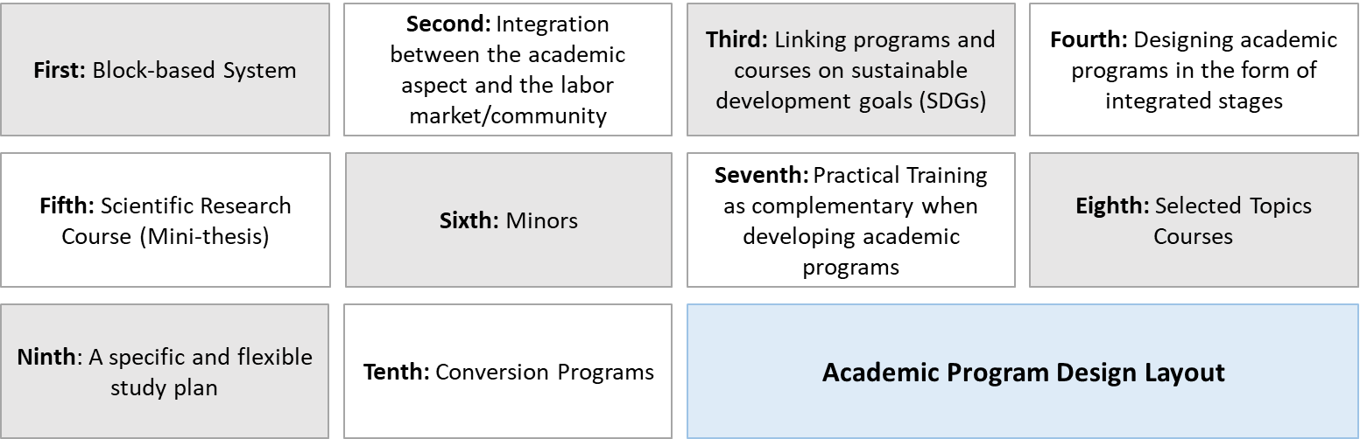
Figure 2: Layout of Academic Program Design.
First: Block-based System
Every course can be addressed through diverse and integrated teaching and learning methods, ensuring that students' interaction is in line with the thought of the fourth – generation universities. For instance, the desired educational outcomes can be realized through seminars, peer teaching, projects, collaboration with business sector partners, and traditional academic classes. Additionally, academic activities are fostered beyond the regular educational frameworks through a unified and instructional system to encourage the establishment of “student chapters” as an opportunity to enhance student integration and interaction inside the campus, locally, and even regionally and internationally (Figure 3) (Annex 3).
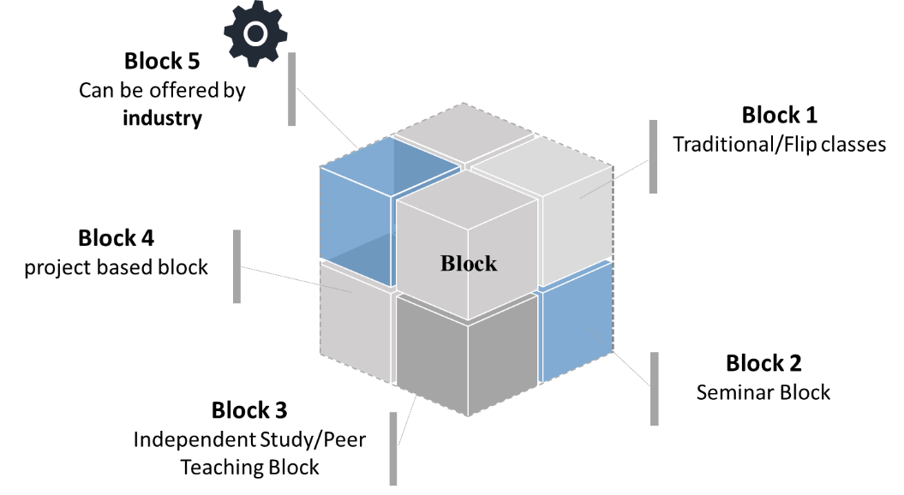
Figure 3: Block-based Course System
Second: Integration between the academic aspect and the labor market/community
This integration between the business sector, community needs and academic education fosters the realization of educational goals and the provision of successful opportunities for students. Interaction allows for updating curricula and guiding students towards essential labor fields, since it provides applied practical experiences to students after graduation. This enhances students’ understanding of the business sector’s needs and their preparedness for employment and contributes to developing communication and teamwork skills. Employability and association between educational institutions, community needs and economy are also fostered by this interaction.
- Methodology for academic integration with business sector/society
- Setting clear and measurable goals for the communication strategy.
- Identifying stakeholders to secure balance with the educational objectives.
- Surveying a sample represented by relevant parties/stakeholders.
- Promoting teaching and learning methods, as well as practical training programs to develop a real work experience with the business sector.
- Enabling networking between students, faculty members and stakeholders.
- Supporting continuous communication with graduates (to exchange benefits).
- Allocating resources and support for the execution of the communication strategy.
- Periodic evaluation by using remarks and performance indicators.
- Advisory Board (Business Sector-Stakeholders)
Establishing an advisory board that comprises participants from the business sector or experts from various fields, closely related to university educational institutions, provides opportunities for fruitful interaction between academics and business owners. This integration significantly bolsters the identification of the business sector/stakeholders' needs and guides educational disciplines towards fields of high demand, thus strengthening the graduates' employability. Moreover, the Board shall contribute to developing practical educational programs and establishing active partnerships with the business sector/stakeholders, providing opportunities for training and employability, contributing to the improvement of education quality and stimulating innovation and constant improvement (Figure 4). Forming the Advisory Board requires a meticulous and deliberate process to ensure effective representation and achieve constructive interaction between the educational institution and stakeholders. The following steps are required for the formation of the Advisory Board:
-Defining objectives: Clearly define the Board’s goals and objectives, ensuring their consistency with the university education objectives and the business sector/society needs.
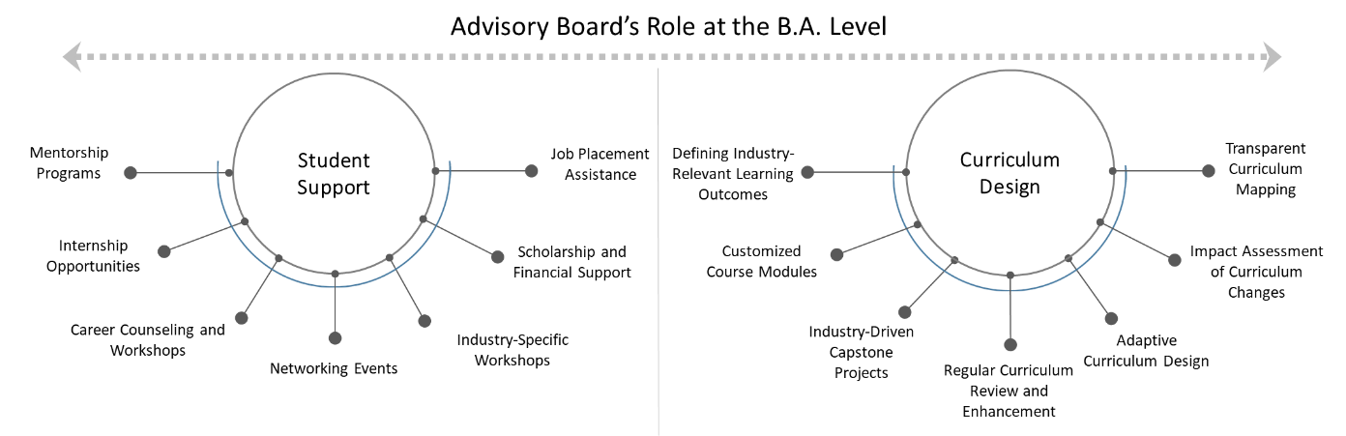
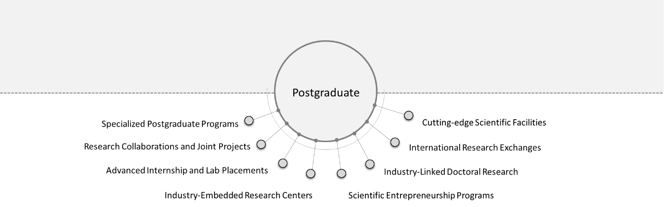
Figure 4: Roles of Advisory Board at B.A. and Postgrad Levels.
-Defining main fields: Defining main fields which need counselling and guidance from the business sector, such as curriculum development, market guidance, and training opportunities.
-Selection of members: Selection of board members according to specific criteria set by the educational institution, while considering diverse representation of various relevant industries and sectors, in addition to graduate inclusion.
- Inviting potential members to join the Board: Inviting potential members to join the Board, clarifying the expected objectives and responsibilities.
-Foundational meeting: Holding a foundational meeting to determine the Board's role and responsibilities and define members' expectations and future plans.
-Defining the organizational structure: Defining the Board's internal organizational structure, defining the responsibilities and timeframes of meetings.
- Facilitating communication: Providing effective means of communication between the Board and the educational institution, including the use of technology and holding meetings.
-Performance assessment: Regular assessment of the Board's performance to ensure the attainment of the set objectives and constant improvement.
-Integration with the Administration: Ensure constant integration with the educational institution's management to secure harmonious efforts and achieve a positive impact.
Overall, the formation of the Advisory Board requires good collaboration and communication between academics, representatives of the business sector and stakeholders to ensure realization of expected outcomes of such networking.
Third: Linking programs and courses on sustainable development goals (SDGs)
Linking academic programs with sustainable development goals (SDGs) enhances sustainability through raising awareness and developing student skills. Furthermore, it boosts critical thinking and social responsibility, promoting innovation and research in fields that contribute to sustainable development. This link leads to the integration of knowledge and strengthening the reputation of the educational institution, directing its efforts towards facing environmental, social and economic challenges. The 17 SDGs are a series of goals set by the United Nations to achieve sustainable development by 2030. These goals were adopted in September 2015 as part of the global agenda to realize sustainable development (Figure 5) (Annex 3).
Global Goals for Sustainable Development |  | 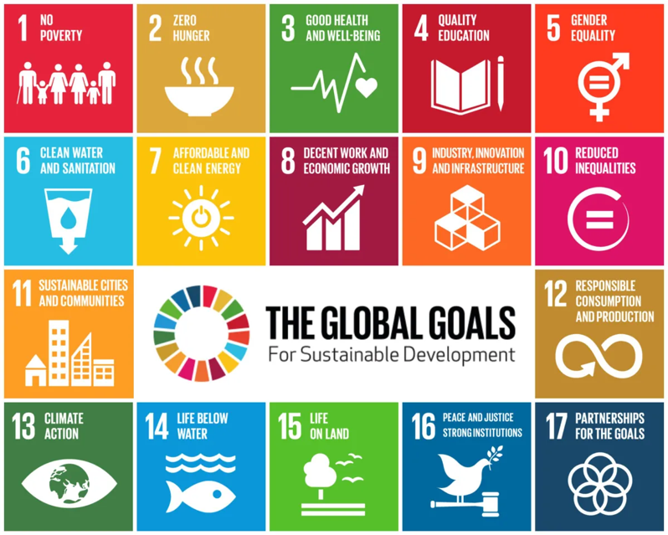  Figure 5: 17 Global Goals for Sustainable Development.
1 | No Poverty: Poverty eradication of all forms, everywhere.
2 | Zero Hunger: Eradicate hunger, realize food security, improve nutrition and promote sustainable agriculture.
3 | Good health and well-being: Ensure a good healthy lifestyle and well-being for everyone of all ages.
4 | Quality education: Ensure the provision of good education and lifelong learning opportunities for all.
5 | Gender equality: Achieve gender equality and empower all women and girls.
6 | Clean water and sanitation: Ensure provision of clean water and sanitation for all.
7 | Ensure access to affordable, clean and sustainable energy for all.
8 | Promote inclusive economic growth, providing decent job opportunities for all.
9 | Build a solid and resilient infrastructure, sustaining the business sector and innovation.
10 | Reduce inequalities within and among countries.
11 | Make cities and human settlements inclusive, safe and sustainable.
12 | Ensure sustainable consumption and production patterns.
13 | Take immediate measures to combat climate change and its impact.
14 | Protect life below water and its sustainable utilization.
15 | Protect life on land and combat the extinction of organisms.
16 | Sustain peace, justice and strong institutions.
17 | Promote partnerships for the goals.
Fourth: Designing academic programs in the form of integrated stages
Academic programs can be designed as integrated stages comprising one or more study levels. This means that the final level of such a stage is a "Pivotal level", where transition from such level to the next can only apply under specific conditions set by the educational institution (Figure 6):
- The student shall complete all academic courses at this stage.
- The student shall acquire a specific cumulative GPA, which may be similar to the minimum required grade for graduation.
- (Previous points are suggestions to be considered or complemented by other suggestions according to the nature of the program, rules and the applicable regulations).
Example: An academic program comprising four levels and two stages.
A second integrated academic stage (at the end of the program, the academic degree of the entire program is granted).
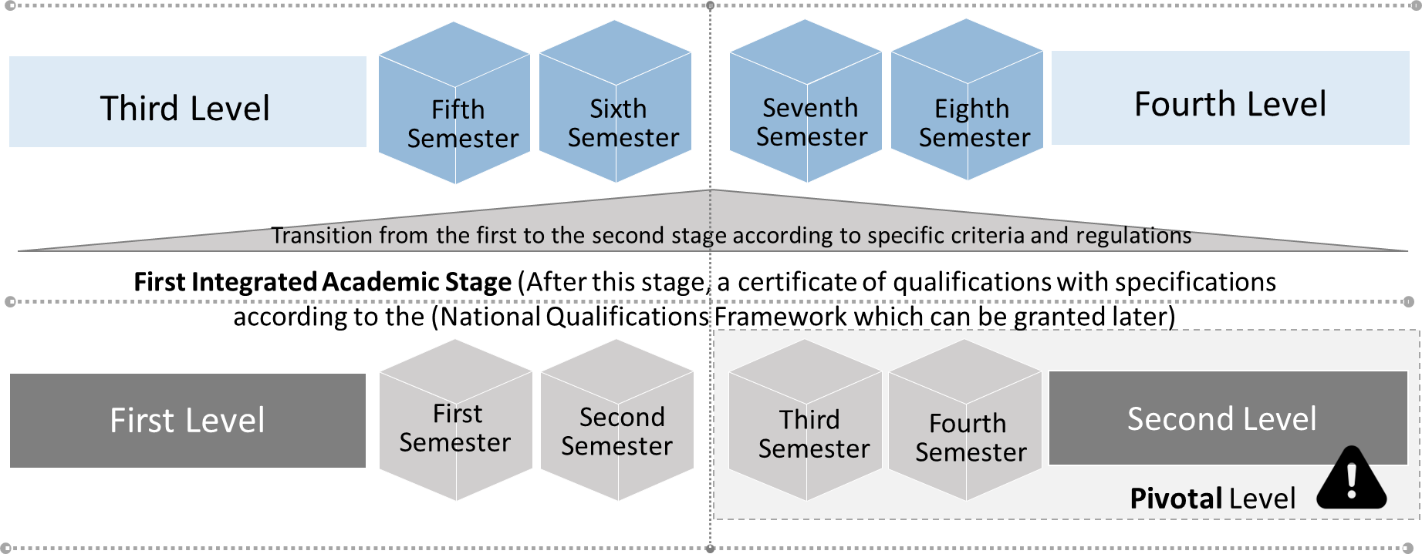
Figure 6: An example illustrating the concept of integrated academic stages within a single academic program.
The program design strategy aims to (Figure 7):
- Ensure student progression to advanced levels, completing courses at lower levels, and this facilitates the student's academic pathway.
- Facilitate course improvement.
- Ensure efficient student progression to higher levels (Minors).
- Later complementarity with the idea of awarded certificates (upon completion of one integrated level without completing the overall study program to receive the final grade), based on the concept of "National Qualifications Framework" (The National Qualifications Framework offers a unified framework for classifying and understanding qualifications. It is used to facilitate interaction between educational institutions and the business sector, promoting transparency in the transfer of qualifications. It also contributes to improving the quality of education and facilitates transition between education and training levels).
- Endorse the idea of stage-based study with partial certificates that help in the early exit of students who desire /need to join the business sector at early stages. This, in turn, leads to the decreased number of students at advanced stages (hence relieving the government's subsidy burden in higher education).
- Inject human energy and early integration into the business sector, hence adding an economic dimension. The student is also permitted to return and complete the educational pathway within a period approved by the educational institution, in return against tuition fees set forth by the institution (This is considered a source of income for the educational institution, enabling its continued improvement and development).
- Open horizon for completion of advanced stages after acquisition of additional skills through the student’s experience in the business sector. This contributes to efficient re-integration of the student to pursue the educational pathway and enrich the educational system with the diverse experiences of the students enrolled in the academic program.
- Support the idea of transition between academic and technological higher education (See item 6: Higher Technological Education Pathway, p. 17).
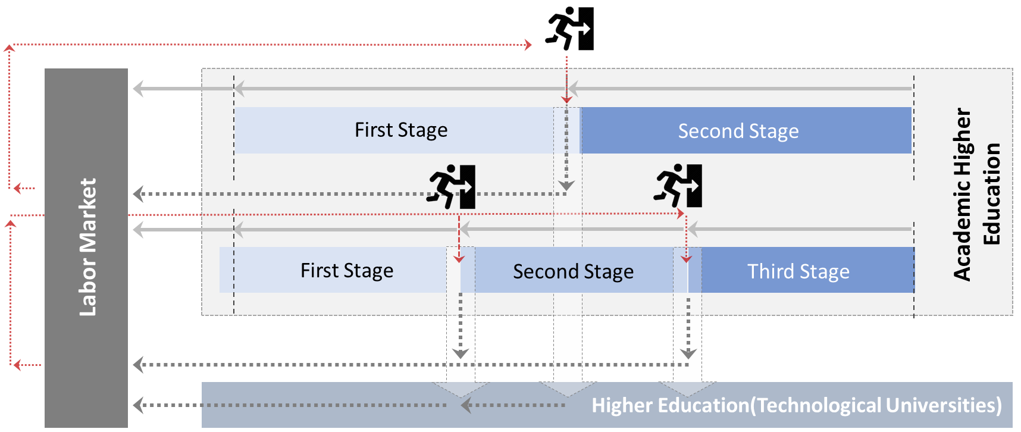
Figure 7: A strategy for designing academic programs in the form of integrated stages that support pathway diversity and reinforce the concept of differentiation and uniqueness.
Based on the idea of designing academic programs as integrated stages, the "Conversion pathways" concept notably indicates an academic pathway or program designed for holders of present degrees, but who wish to convert to a different academic field or discipline. These programs can be at the B.A. or postgraduate level. The purpose is to enable individuals who have a background in one field to acquire the necessary knowledge and skills in a different field. Below are some key points about the conversion programs and their benefits:
- Professional transition:
These programs offer a pathway for individuals who desire to change the professional field. Individuals who initially obtained a degree in one field can use conversion programs to acquire relevant qualifications.
- Fulfill the needs of the variable business sector:
Often, conversion programs are designed to fulfil specific needs in the business sector. These programs provide individuals with skills currently required by the business sector; they help bridge the gap between labor force needs and available qualifications.
- Increase job opportunities:
Completing the conversion programs promotes job opportunities for the graduates as they provide them with the necessary skills and qualifications in a specific field. This can boost graduates' competitiveness in the business sector and increase their employability in the field that meets their needs.
- Personal and professional growth and diversity of skills:
Conversion programs allow individuals to diversify their skills and broaden their knowledge base through transfer to a new academic pathway. This is specifically useful for those who desire to explore different job opportunities or adapt to changes in the business sector.
- Efficient and effective time management:
Since participants in the conversion programs already hold a degree, these programs are often more intensive and with a shorter span than usual university programs. This allows individuals to acquire the necessary skills in a shorter time and rapidly return to the business sector.
Generally, the conversion programs in higher education aim to facilitate professional transition, address the skill gaps in the business sector and support personal growth and lifelong learning. Additionally, these programs offer individuals an opportunity to acquire new knowledge and skills, promoting their professional opportunities in the dynamic and competitive business sector.
Fifth: Scientific Research Course
Adding a course that teaches students how to prepare scientific research at the advanced academic stage (Postgraduate levels of the academic program) is highly beneficial for the "lifelong learning" philosophy. This is affirmed by the fourth generation universities and aligns with the standards of higher education program accreditation issued by the National Authority for Quality Assurance and Accreditation (NAQAAE) (July 2022) stipulating the "application of teaching and learning methods that encourage students to actively take part in their educational process, support their self-learning process, develop higher thinking skills as well as boost their employability and entrepreneurial skills. The program also provides professional development methods and continuous learning activities to the graduates to keep abreast of recent updates and developments in the business sector". This significance can be clarified as follows:
- Developing research skills: Students can learn the fundamentals of research, methods of research, use of reliable sources, as well as analysis of information and expression of opinion about this information.
- Promoting critical thinking: The course enables students to develop critical thinking skills in the analysis of topics and evaluation of evidence and arguments.
- Improving academic writing skills: Students learn how to draft their ideas structurally and logically and write scientific texts that fulfill the standards of academic quality.
- Developing independence: This course encourages students to work on their own in preparing their dissertations, thus promoting their self-learning skills and personal organizational skills.
- Reaching a deeper understanding of the topic: Through writing scientific research (mini thesis), students acquire a more profound understanding of the topic and become more conscious of their chosen field.
- Preparing for professional life: Preparing scientific research in this stage is regarded as an essential part of preparing for professional life, where students acquire valuable skills of potential benefit in research and writing fields across their professional and future pathways.
- Contributing to knowledge: These courses can offer opportunities to students to contribute to scientific and academic knowledge through adding new aspects or discoveries in the field under research.
Developing the afore-mentioned skills through preparing a full thesis can be invested in supporting the academic relationship and scientific research between undergraduate and postgraduate students. The staff member supervising the undergraduate students represents the link between them and their peers at the postgraduate stage who are supervised by the same staff member, strengthening mutual benefit between the parties. For example, this thesis can become the nucleus for a research project in which students of both stages participate. Furthermore, the research of the undergraduate students will provide a practical benefit for a postgraduate student (they may be in another country). Therefore, the benefit of scientific research increases while preserving the moral rights of both parties. This relationship significantly helps:
- Increase the added value of scientific research
- Support applied results
- Promote international publication
- Secure intergenerational communication which can open broader horizons.
This course could end by promoting the idea of international publication at the B.A. level. If the student manages to publish in a scientific journal with a minimum (Q2) rating according to the Web of Science, the student can receive an “A” grade even if the original assessment of the course is less than that (Figure 8).
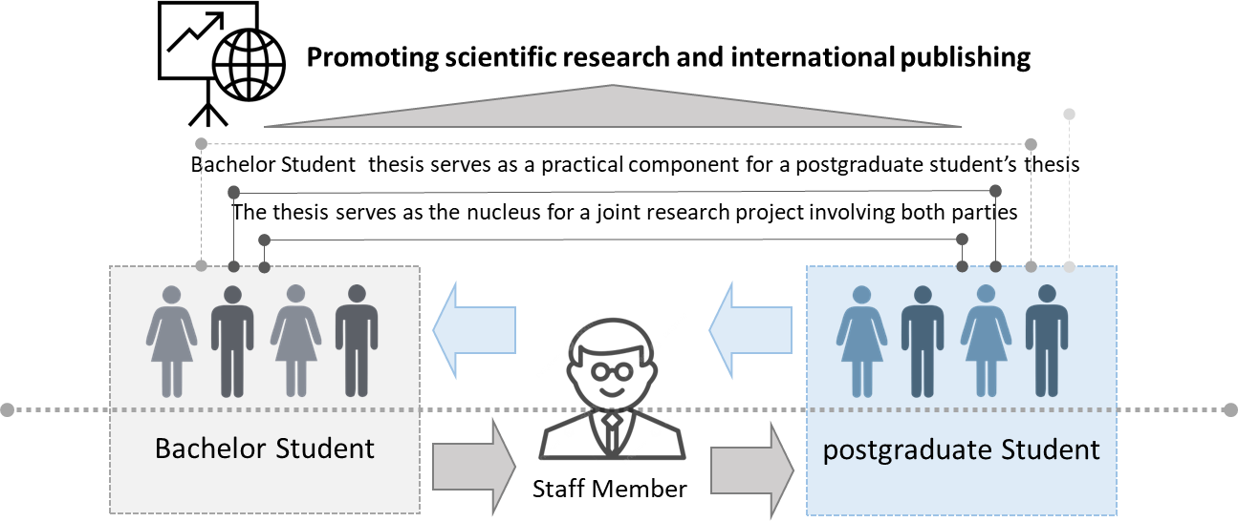
Figure 8: Scientific Research Course and the Reciprocal Relationship Between Undergraduates and Graduates.
Sixth: Minors
"Minors" indicate minor academic fields or disciplines that students can cover in addition to their major study. They are called "minor" because the student can acquire knowledge in a specific field through lesser academic modules compared to the major discipline. Enrollment in “minors” is elective and with tuition fees set by the regulations. This minor discipline is available for students outside the faculty or university. The duration of the study is equivalent to a whole semester (from 12 to 18 credit hours, and some minors may require up to 30 credit hours), with changes to such rules according to the requirements and rules specified by the educational institution. This minor can be in a specific field different from the major in the bachelor’s degree or can be complementary to the major (Annex 4).
Minors are highly significant for the following reasons:
- Increase of sources of income for educational institutions.
- Alignment with the business sector and continuous learning concepts, as previously stated. Minors are open for registration for individuals not registered as regular students in the educational institution, in line with the continuous learning policy adopted by the National Strategy for Higher Education and Scientific Research.
- Promotion of the principle of interdisciplinarity, supporting knowledge required by the business sector.
- -Targeting a further specialization depth, which helps create new job opportunities in addition to a faster integration with business sector needs, as well direct and rapid benefit from human potentials.
There are other ideas and patterns listed under the same idea. Overall, incorporation of minors in the design of academic programs offers an inclusive and customizable learning experience, enhancing intellectual curiosity and embracing a multi-dimensional learning approach.
Seventh: Practical Training as complementary when developing academic programs
Training must be a main requirement for graduation in university education. Practical training can be integrated into the courses through designing educational programs that include practical training periods, practical projects, and direct cooperation with the business sector. Therefore, students will have an opportunity for professional practice prior to graduation and later improvement of their academic attainment through dealing with real challenges in the work environment. This is on condition that the educational institution offers training opportunities supported by local and international partnerships, and this impacts the efficiency of the institution's performance in several axes (education, research and community service). In this regard, training can be:
- Internal training: provided by the educational institution's centers and units.
- External training: provided by local and governmental bodies, the private sector or international agencies, based on cooperation partnerships and protocols in line with the learning skills and outcomes required in the academic program.
- Local or international competitions.
- Professional certificates are deemed training modules (where the educational institution releases a list of internationally recognized professional certificates (OSHA-NDT-LEED AP-IASP-IPMAC-CCNA…etc.) and their equivalent workload. In case the student obtains one of these certificates, they are deemed a training program with the period equivalent to the equivalent workload.

 Thread: A Professional Academic Training Program
This is a professional academic training program, probably collaborative with a partner from the business sector or through a unit inside the educational institution and may be project-based. In "Thread", students choose an academic sequence across two study levels (study can extend to one or two years) (Figure 9). This training type holds a significant value as follows:
- Acquisition of competencies/learning outcomes that better correspond with the business sector’s needs.
- Professional qualification of students through their preparation for work as entrepreneurs, innovators and discoverers.
- Preparing an employable graduate ready to acquire direct experience in their field (Business sector associate participating in training pathways).
- Expansion in the possible alignment with the business sector and creation of a business-friendly environment, supporting communication and collaboration between the two sides (academia and the business sector).
- Openness to global education systems and attracting partners from the business sector internationally and the international companies accustomed to such collaboration with the academic sector through these systems. This aids in program internationalization and accelerated increase of universities ranking.
- Upon completion of such study, the student can acquire a professional/ specialized technical certificate "Micro-credential".
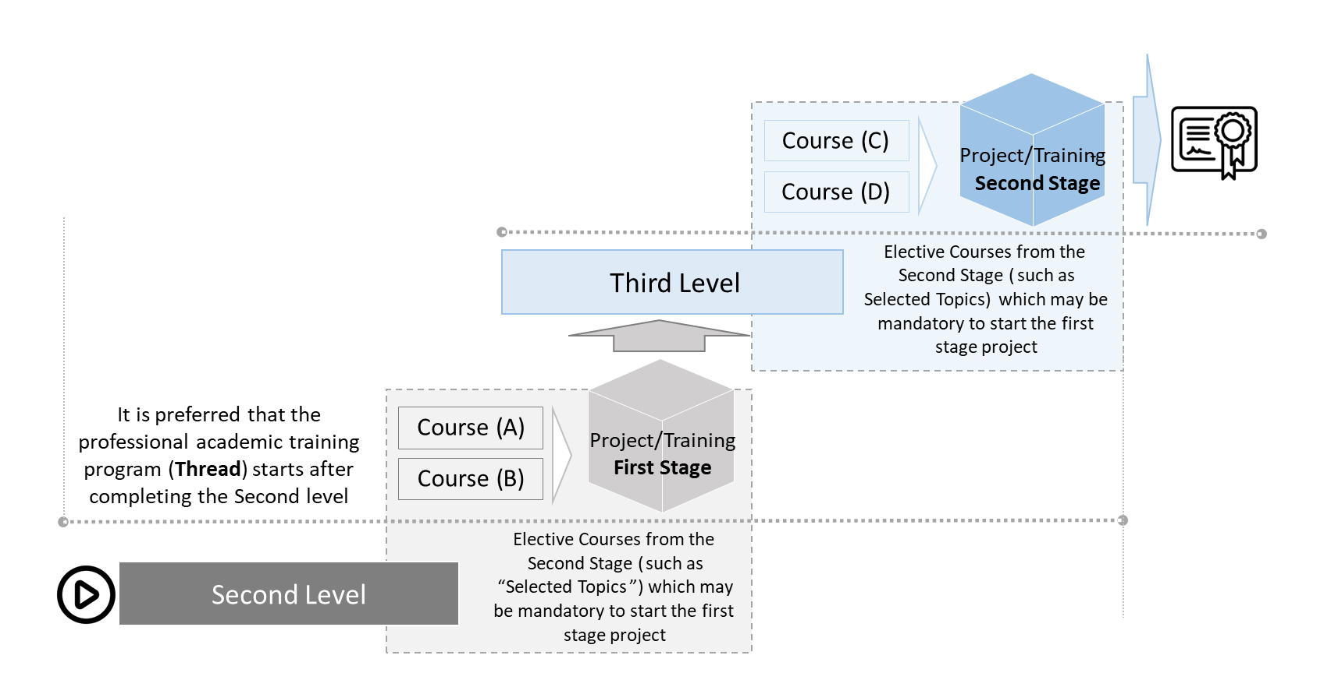
Figure 9: An example illustrating the concept of a project-based professional academic training program (Thread).

Eighth: Selected Topics Courses
Offering "selected topics" courses as mandatory courses in developing academic programs at postgraduate studies level allows students to explore diverse topics which may not be thoroughly addressed in the main curriculum. These courses offer instructors "flexibility" of customizing content based on current trends, emerging issues or fields of particular interest. Offering such courses is highly significant to enhance response to current issues and promote critical thinking through the opportunity to explore complex topics, as adopted by fourth generation universities. These courses also offer flexibility to students to choose fields of study suitable to their interests or professional interests (It may be an incentive for enrollment in one of the available secondary programs "Minors", boosting the educational experience and giving room for an individual learning journey. These courses are supportive of professional academic training programs "Thread". Hence, they contribute to developing professional skills and endorsing a multi-disciplinary problem-solving approach (Figure 10).
Ninth: A specific and flexible study plan
The academic program regulations must ensure a specific and flexible study plan. This means offering courses in Autumn only and others in Spring only. Some courses can be offered in both semesters according to the proposed study plan. Freely offering all courses represents a burden on the financial and/or human resources of the institution. Nevertheless, the potential offering of courses other than in their specific semester can be allowed, in accordance with the institution's requirements and in return for tuition fees. Regarding Summer courses, these are subject to certain standards and with tuition fees (Figure 11).
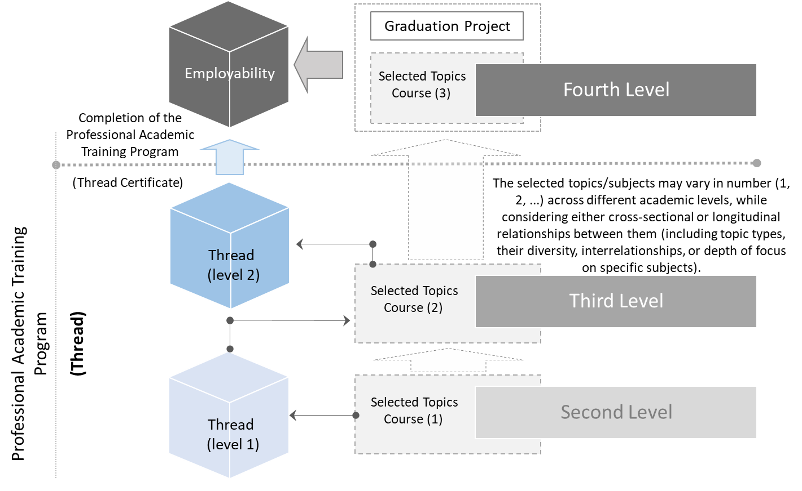
Figure 10: Selected Topics Courses and Their Potential Integration with Professional Academic Training Programs (Thread).
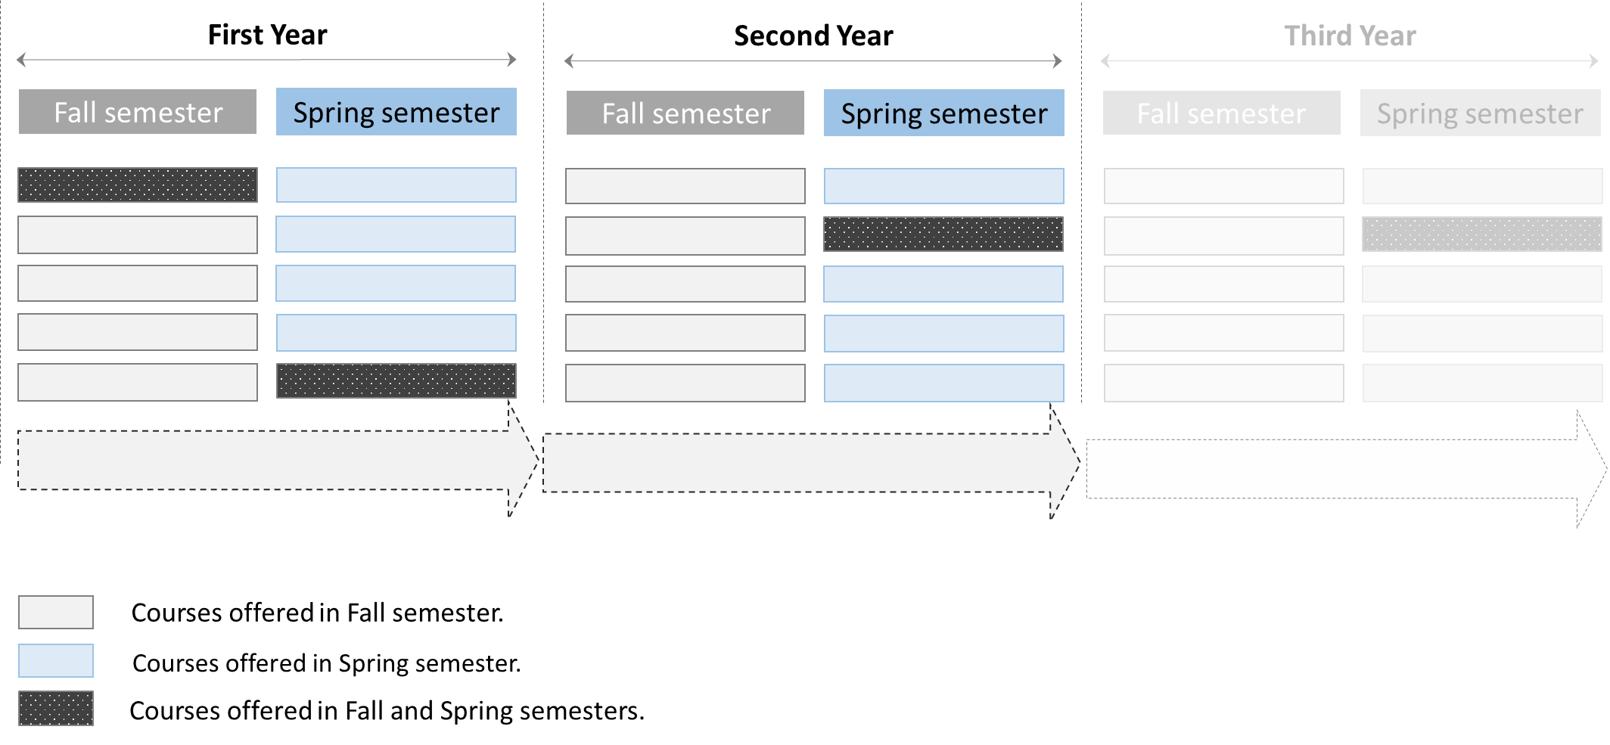
Figure 11: A diagram illustrating the concept of having a defined yet flexible study plan.
This is without prejudice to Article 21 of Egyptian Constitution stipulating that "The State shall guarantee the independence of universities and scientific and linguistic academies and provide university education in accordance with international quality standards. It shall develop and ensure free provision of university education in public universities and institutes according to the Law. This system maintains the advantages of the credit hour system in line with financial and human resources (Figure 12).
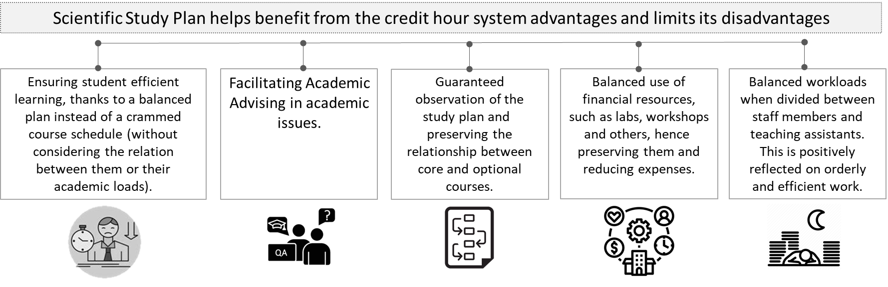
Figure 12: Benefits of Specific and Flexible Academic Plan.
Tenth: Conversion Programs
In higher education, the "Conversion programs” notably indicate an academic pathway or program designed for holders of degrees, who wish to convert to a different academic field or discipline. These programs can be at the bachelor or postgraduate level, and they enable individuals who have a background in one field to acquire the necessary knowledge and skills in a different field. Below are some key points about the conversion programs and their benefits:

- Professional Conversion:
These programs offer a pathway for individuals wishing to change a professional field. Individuals who initially obtained a degree in one field can use conversion programs to acquire relevant qualifications.
- Fulfilling the needs of the variable business sector:
Often, conversion programs are designed to fulfil specific needs in the business sector. These programs provide individuals with skills currently required by the business sector, thus helping bridge the gap between labor market needs and available qualifications.
- Increase job opportunities:
Completion of the conversion programs promotes job opportunities for individuals by providing them with the necessary skills and qualifications in a specific field. This can boost graduates' competitiveness in the business sector and increase their employability in the field that meets their needs.
- Personal and professional growth and diversity of skills:
Conversion programs allow individuals to diversify their skills and broaden their knowledge base through transfer to a new academic pathway. This is specifically useful for those who desire to explore different job opportunities or adapt to changes in the business sector.
- Efficient and effective time management:
Since participants in the conversion programs already hold a degree, these programs are often more focused and less in duration compared to usual university programs. This allows individuals to acquire the necessary skills in a shorter time and rapidly return to the business sector.
The conversion programs in higher education aim to facilitate professional transitions, address the gaps in skills in the business sector and support personal growth and lifelong learning. These programs also offer individuals an opportunity to acquire new knowledge and skills, promote their professional opportunity in the dynamic and competitive business sector. Finally, this layout operationalizes the principles of the Higher Education Strategy 2023. The following matrix clarifies the relationship between these principles and the layout axes for designing academic programs (Table 1):
Table 1: Matrix of the Relationship between the principles of the Higher Education Strategy 2030 and the academic program design layout.
Layout of Academic Program Design | Principles of Higher Education Strategy 2030
Layout of Academic Program Design | Integration | Interdisciplinarity | Communication | Active Participation | Sustainability | International Reference/Benchmark | Leadership and Creativity
First: Block-based System
Second: Integration between the academia and the labor market/community
Third: Linking academic programs and courses with sustainable development objectives (SDGs)
Fourth: Designing academic programs in complementary stages and conversion programs
Fifth: Scientific Research Course (Mini thesis)
Sixth: Minors
Seventh: Practical Training as a complementary part when developing academic programs
Eighth: Selected Topics Courses
Ninth: A specific and flexible academic plan
Tenth: Conversion Programs

  - Rules of academic frame of reference
Below is a group of procedural rules for the development of academic programs:
- Determination of the first step in academic program design, according to thorough studies and benchmark comparisons considering the business sector requirements locally, regionally and internationally. These studies and comparisons also observe standard requirements and the local and international accreditation bodies of academic programs. Required knowledge and skills are determined according to such standards, then a plan is visualized for courses required to be studied at the last study level. This plan progresses in a descending order for prerequisite courses, then courses before it and so forth until the last level. This is based on students’ knowledge and skills when they are enrolled in the first university stage.
- Preparing a list of competencies/learning outcomes that the student must acquire, based on specific graduate qualities, and clarifying the extent and manner of acquiring these competencies/learning outcomes through the proposed courses (through the matrix linking courses to competencies/learning outcomes and the student-centered courses to ensure that lifelong learning value is realized).
- Designing courses to be horizontally and vertically integrated, ensuring the development and sequence of competencies and content in an integrated structure, while taking into consideration non-repeated or deficient scientific content (unless in different contexts) leading to a dysfunction in earning competencies/aspired learning outcomes.
- Selection and design of elective courses for their vital role in improving student experience in higher education. Providing opportunities for choosing between relevant courses in the major discipline allows students to deepen or broaden their understanding in their field of study. These courses enhance interaction in classes and enable students to acquire additional skills that support their academic attainment and promote diversity in their scientific experiences. This leads to their better preparation to meet the business sector requirements and face future challenges.
- Examining and designing courses classified as requirements of the educational institution as a main pillar in establishing and expressing the institution's identity, either academically or regionally (across the seven regions of Egypt), where these courses form the main pillar of the institution's academic orientation and the human/societal dimension. This fosters the integration of knowledge and complements majors with profound skills. Hence, this balance greatly contributes to realizing the University's vision and ascertains its identity and integration locally.
- Integration of the practical/applied part as a basis in courses, to act as the backbone of learning methods (if possible), ascertaining that students are "active" in their educational pathway and stressing academic integration with the business sector in preparing courses.
- Integration of technology, research and innovation in courses to improve educational experience. This is doable through using innovative learning curricula, using digital media (such as virtual and mixed reality techniques) and encouraging students to participate in research activities /projects locally and internationally. This integration enhances the skills of research and innovation, and it can be applied by reviewing objectives of the practice hours and their method of work and whether they adopt the student-centered education.
- Continuous development of main skills considering the rapid transformations in the business sector. The World Economic Forum's report on future jobs released in 2023 lists a group of main skills expected in the business sector (Annex 5) including the skills of analytical thinking, innovation, effective communication and understanding technology. These skills have a vital role in determining the chances of success in the contemporary work environment and they can be acquired through the following:
- Academic courses adopting teaching and learning methods aligned with the above-mentioned philosophy.
- Practical/field training as a prerequisite for graduation.
- Academic extracurricular activities (such as student chapters of international scientific organizations and non-academic activities (such as cultural, artistic and sport activities and events).
- Applying teaching and learning methods that include availability and inclusivity.
- Activating the role of assessment from the business sector (through advisory boards formed in each institution) as well as graduate assessment of constant development in academic programs.
- Diverse assessment methods of student performance through different course activities appropriate to the nature of the course, and integration of activities that support learning and application without a formative assessment. Other methods use summative assessment when specific milestones are completed. Continuous assessment is favored, with results announced to students.
  - Frame of reference determinants of academic regulations at the B.A./B.Sc. level
Upon development of academic programs, a set of determinants must be taken into consideration:
- Vision and mission
The first clauses of the educational institution regulations comprise the institution's vision and mission, as well as the content of granting academic degrees and names of these degrees.
- Percentage of various science courses
The program design must contain clear percentage of different courses according to the requirements of the scientific sector.
- Classification of graduation prerequisites
Classification of topics included in the academic program for graduation prerequisites as follows (Table 2):

Table 2: Classification of Graduate Prerequisites.
Prerequisites | Main Components
University/Institute Prerequisite | Developing graduates' cultural personality, development  of personal skills and general awareness of social issues, while focusing on identity and connection to homeland
Scientific Sector Prerequisite | Minimum limit for basic sciences across all disciplines
Major Prerequisites (If any) | Specialized courses
Minor Prerequisites (If any) | Special and distinct courses of the program

The program hours can be distributed on the graduate prerequisites as follows in (Table 3):
Prerequisites | Minimum % |  | Maximum%
General Prerequisites | -- |  | --
Scientific Sector Prerequisites | -- |  | --
Major Prerequisites (If any) | -- |  | --
Minor Prerequisites (If any) | -- |  | --
Table 3: Distribution of Program Hours on Graduate Prerequisites.

- Interdisciplinary programs
For interdisciplinary programs combining two or more disciplines, they include the university prerequisites and replace the major and minor prerequisites with a set of requirements for disciplines sharing the nature of this program.
- Course coding system
- The educational institution (Faculty/Institute) offers academic programs. Each of the scientific departments at the Faculty/Institute teach the courses under its discipline in any academic program. The institution monitors the performance of the staff members and refers the staff members' performance report to the relevant department.
- Courses are directly linked to the scientific department; hence the course code determines the department which teaches the course. Courses are coded in a way that links the course to the scientific department offering it. The first part of the course code is the scientific department's code, and the second part of the course code represents the year or level.
- Total Student Workload (SWL)
- The academic regulation can be designed according to one of the following systems (Annex 6):
- The American Credit Hour System.
- The European Credit Hour System.
- The Successive Study System (modified semesters).
- The total contact hours of the student in the semester shall not exceed the limits prescribed by the scientific field, to ensure alignment between the academic regulations at Egyptian universities and their counterparts at international universities.
- We need a scale by which the Egyptian education system can be compared to global education systems. Using credit units in world systems may be one of the methods used in the comparison. After the emergence of the European system, the student workload "SWL" started to be used. It represents the total hours of study of the student: Attendance of lectures, conducting experiments, solving exercises, searching for information, and all that is related to studying (whether at the university, house, or any other entity where work related to studying there must be completed). Below is a comparison between the American and European systems, representing the most famous higher education systems.

American system (Credit Hours)
The programs follow a credit-hour (CH) system. This is the scale of contact hours between instructors and students in the academic semester, where one credit hour is equivalent to hours of contact as follows:
- One-hour lecture per week for a 15-week semester.
- Two practical hours per week for a 15-week semester.
- Three-hour lab per week for a 15-week semester.
One contact hour is divided into 50 minutes actual teaching and 10 minutes break.
1 Cr. Hr. 1 Cr. Hr. Lecture + 2 Hrs. of Student free work 3 hrs. of SWL / Week.
5-6 Courses/Semester, each one 3 Cr. Hrs. 45-54 hrs. Total SWL / Week.
15 Weeks/Semester 720-864 Total SWL / Semester.
European System (ECTS):
1 ECTS Unit 25 SWL / Semester.
30 ECTS / Semester 750 Total SWL / Semester.
Egyptian System (Contact Hours):
3 Contact hrs. Course 2 hrs. Lecture + 1 Hr. Tutorial + 3 hrs. Student free work.
25 Contact hrs./week for 15 Week/Semester 750 Total SWL / Semester.

Comparing the total student workload, we deduce the following approximate equation:
18 Cr. Hrs. ≈ 30 ECTS ≈ 25 Contact Hrs.

- Requirements to obtain a degree
- Each committee of the higher education sectors undertakes to identify the following:
- Minimum requirement to obtain the grades/points/GPA for all program courses as a prerequisite to obtain the scientific degree.
- Courses to be passed with assessment (Pass/Fail) and which are not considered in the GPA, such as summer training courses, seminars, etc.).
- Conversion from one program/discipline to another inside the educational institution, pursuant to the institution's regulations and internal rules approved by the institution's board annually.
- Academic Courses Grades
The grade of each course is calculated according to the marks obtained during the study of the course (activities-mid-term assessment-continuous assessment-final assessment). The following table clarifies how the grade is calculated and the number of equivalent points from the marked obtained. The student must obtain the minimum grade (D) to pass the academic course, and the equivalent points are used in calculating the semester GPA and cumulative GPA of the student. The marks are distributed across various evaluation patterns in the course description table in this regulation. The faculty board may modify mark distribution due to the different nature of the program, upon the request of the competent department council, provided that the result is announced to students before the beginning of the academic semester (Table 4).
Table 4: Course marks and grades and the number of equivalent points.
Percentage of the Mark | Grade | No. of Points
97% or more | A+ | 4.0
93% to less than 97% | A | 4.0
89% to less than 93% | A- | 3,7
84% to less than 89% | B+ | 3,3
80% to less than 84% | B | 3,0
76% to less than 80% | B- | 2,7
73% to less than 76% | C+ | 2,3
70% to less than 73% | C | 2,0
67% to less than 70% | C- | 1,7
64% to less than 67% | D+ | 1,3
60% to less than 64% | D | 1,0
Less than 60% | F | 0,0

- Transcript
The transcript is a vital academic document of high significance, since it is crucial in detecting and assessing student's academic performance and progress. The transcript involves details about the student's marks in a set of courses and academic subjects, reflecting the student's understanding of the content and achievement of the educational goals. The transcript is also a tracking tool for the student's academic pathway, thus requiring an electronic system. It also serves as a comprehensive image for the student, to be used as an assessment tool of personal abilities and general skills. Moreover, this transcript allows decision-makers, whether employers or admission committees in postgraduate studies, to examine the details of student's performance progress. The transcript is an essential tool to reflect the comprehensive assessment of the student and his/her preparedness for the business sector.
Issuing a comprehensive transcript is sufficient for students instead of issuance of numerous statements required from students upon graduation to present to an employer or a foreign university with information not included in the certificate, such as a statement of study in English language, number of hours, contact hours, enrollment prerequisites, national identity number, student's rank in their class. For these reasons, the transcript can be designed to include the following (Annex 7):
- Student data
- Personal data.
- Description of the scientific degree.
- Qualification and issuing agency.
- General score.
- Academic courses
- Courses and results (one table for all subjects with the addition of the number of contact hours).
- Relationship between the courses and sustainable development goals (SDGs).
- Scientific data (If applicable)
- Measuring the progress of student performance.
- Distribution of subjects among departments (to classify the student according to the different departments, especially interdisciplinary programs).
- Minors.
- Field training and professional academic training programs (Threads).
- International publication.
- Activity and community service.
- List of abbreviations and classification of marks.
- Some regulation subjects.
- Honors.
- Registration/admission requirements.
- Program study period.
- Prerequisites for granting the degree.

- Requirements for introduction of a new academic program
The necessary requirements and standards to introduce one of the academic programs are presented, ensuring response to accelerated developments in the business sector and growing needs and aspirations of society. This proposal is an important step towards achieving a constant balance between market requirements and higher education requirements. Thus, the academic program offered in the B.A. stage, or its equivalent must aim to fulfill these growing needs and achieve sustainable development through provision of a high-quality education that enables students to acquire the necessary skills and knowledge to succeed in the market and actively contribute to community development (Annex 8).
- Preparatory studies
- A feasibility study identifying the need for this discipline in the business sector.
- Conducting benchmark comparisons and studies of similar programs in reputable international educational institutions.
- Conducting a study on the potential available for student field training programs in the surrounding environment.
- Clarifying the extent to which the discipline contributes to serving and developing the surrounding community.
- Determining measurable results that students can expect to achieve upon graduation.
- A comprehensive study of potential /capabilities I. Human potential:
- The minimum ratio of staff members to students must be realized, to have diverse disciplines according to the program's requirement stipulated in each field.
- Develop a prospective training plan for staff members and teaching assistants, if specific knowledge or skill is required to be advanced for the efficient and effective launch of the program.
II. Financial capabilities
- Launch and study at any (program/faculty) starts after provision of the financial capabilities, preparation of labs in the first two years of study and submission of a specific plan to complete the requirements in the two consecutive years of the study.
- For new faculties, other physical requirements must be provided, mainly, facilities, labs, equipment, office and educational furniture, toilets, and means of using modern techniques in teaching.
- Providing the technological infrastructure required for program launch.
- The academic regulations must be adopted and must align with the latest releases of the frames of reference regulating the sector's competent committee.
- Follow-up and performance assessment plan
- Developing a specific plan to follow up the progress of execution and intervention in case of any challenges or problems.
- Identifying main indicators of program performance and quality of the presented education.
- Developing a plan for periodic assessment of program performance and effectiveness of the educational process.
- Program Study System:
- The language of teaching is determined by the program, and the regulations specify the method for verifying student proficiency in the language of teaching if it is not Arabic. Textbooks, exercises, and exams must also be in the language of teaching.
- Newly offered programs must follow the Credit Hour (CH) system, which is a measure of contact hours between faculty and students per semester. One credit hour is equivalent to contact hours, as follows:
  - One-hour lecture per week for a 15-week semester.
  - Two to three hours of exercises and labs per week for a 15-week semester.
- The study regulations must specify the number of lectures, exercises, and lab hours, if any, for each course.
- One contact hour must be specified (which may be 50 minutes of actual teaching and 10 minutes of break time).
- For each course and program, a Student Workload (SWL) must be established. This is defined as "the number of hours of work normally required to complete the learning activities in course units to achieve their expected learning outcomes."
- The total student workload consists of two components:
  - Regular student workload, which is the contact hours assigned to the course.
  - Non-regular student workload, which is the time students spend on self-study, completing course assignments, and preparing for all types of exams, such as assessment workload.
  - ECTS (European Credit Transfer and Accumulation System) is a way to estimate the time and effort required to successfully complete courses. One ECTS (European Credit Transfer and Accumulation System) unit is equivalent to 25 hours of total student work, and each 15-week academic semester should correspond to 30 ECTS units. As an agreed requirement, the total student workload should be 750 hours per semester, or approximately 50 hours of total student workload per week.
  - Proposed values per semester:
  - 16 to 19 credit hours.
  - 25 to 28 contact hours per week for 15 weeks.
  - 750 hours of total student workload.
  - 30 ECTS units.
  - Technological Higher Education Track
In higher education, academic and technological education tracks can converge to form a rich and diverse educational landscape. Each track demonstrates distinct aspects and contrasting learning styles. The academic track reflects a focus on knowledge transfer, theoretical understanding, research, and innovation, while the technological track is based on practical learning experiences, training, practical skills development, and the effective application of concepts. However, this contrast does not imply complete isolation. Rather, it manifests itself in overlaps that enrich the business sector and enhance its diversity and integration (Figure 13). In addition to enriching the business sector, collaboration between the two tracks can begin during the study period, through workshops and joint projects. This interaction ensures a comprehensive learning experience that combines theoretical foundations, research, innovation, and practical applications. In this integration process, it is evident that graduates from both tracks complement each other, where they possess diverse and comprehensive capabilities that enable them to adapt to the demands of the business sector. The following is a comparison between academic education and technological education (Table 5) (Figure 14):
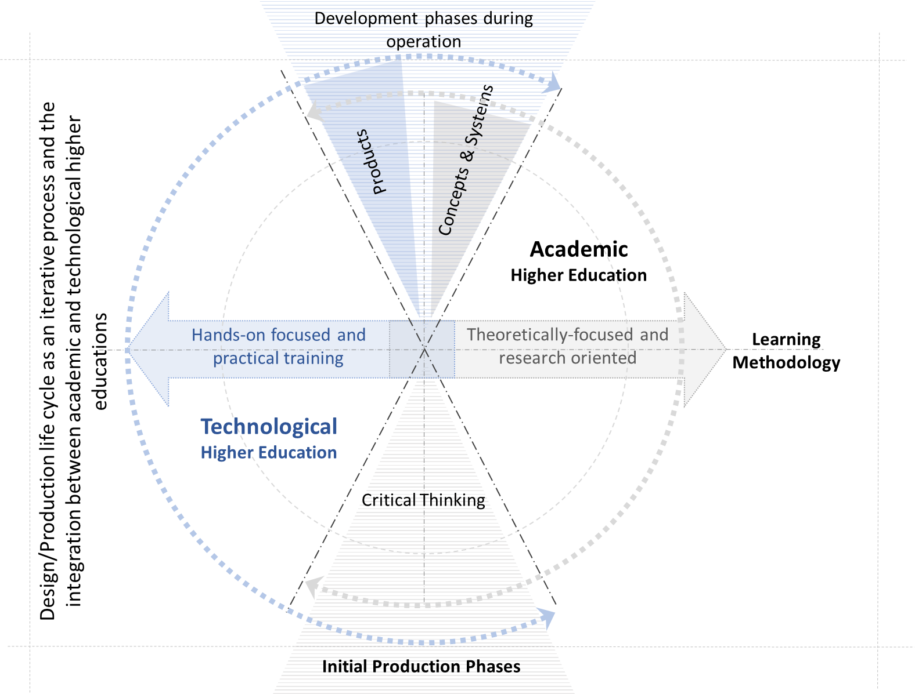
Figure 13: The Relationship between Academic and Technological Higher Education Pathway.

Table 5: Comparison between Academic and Technological Higher Education Pathways.
Comparison Point | Academic Higher Education | Technological Higher Education
Teaching methodology | Theories, Research, and Innovation | Application and Practical Training
Academic degrees | Bachelor of Arts, Bachelor of Science, Master of Arts, Master of Science, PhD | Professional associate degrees, Professional Bachelor of Technology in Specialization, Master of technology/applied sciences, Professional PhD in Specialization
Examples of fields of study | Arts and humanities, social sciences, Life sciences and medicine, Natural sciences, Engineering and technology | Fields of industrial and energy technology, textiles, transportation, advanced manufacturing, computer technology, data science, arts, financial institutions management technology, Business and marketing programs, Applied health sciences technology such as pharmaceuticals, medical devices, and allied health professions in nursing, medical laboratories, Healthcare, Public safety…etc., Hospitality and hotel technology, Tour guiding, Agricultural, animal, and herbal technology
Skills | Research, critical thinking, analysis, creative thinking | Technical skills, critical thinking, operational, maintenance, and testing skills.
Career path | University professors, scientists, writers, consultants, policymakers, analysts, engineers, doctors… etc. | Business and engineering technologists, IT specialists, technicians, robotics programmers, quality control managers… etc.
Educational environment | Most of this involves classroom and research in academic departments, with some laboratory work and internships. | A combination of classroom and practical work in laboratories, workshops and field work
The nature of the programs studied by undergraduate students is divided into two main types:
The first type: depends on a specific study period. The first type includes the full-year system, the semester system, and the academic stage system.
The second type: depends on a specific curriculum and is not strictly limited to the length of study (credit hour system).
Study system and duration | The duration of study ranges between four and five years, and increases in the medical sector | The duration of study is four years. After the first two years, the student may obtain an above-average professional diploma and enter the business sector or complete the two years to obtain a professional bachelor's degree in technology.
Teaching methods | Practical/applied faculties: Scientific presentations, investigation, dialogue, and discussion. This is in addition to techniques such as brainstorming, concept maps, cooperative learning, and problem solving. Theoretical faculties tend to focus on lectures, induction, and reciprocal learning, due to their compatibility with the nature of the theoretical subjects taught in these faculties. | The practical component accounts for approximately 60% of the total course, while the theoretical component does not exceed 40%.  Teaching methods at technological universities are based on linking education and training systems, in addition to cooperative learning, which covers theoretical study. The practical component takes place in institutions, factories, and companies operating in the field of specialization, in addition to the educational institution itself.

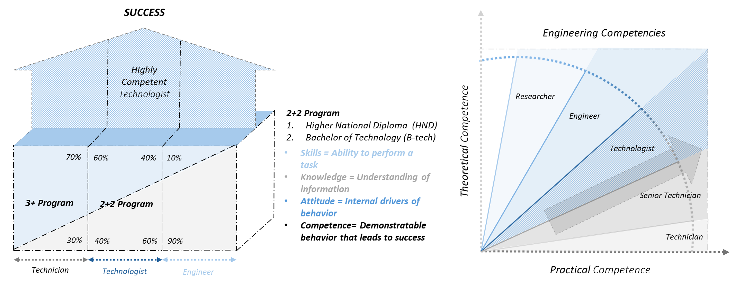
Figure 14: A diagram illustrating the relationship between awarded degrees and competencies in the engineering sector for instance.
Source: NCTU President Dr. Tarek Abdelmalak Mikhail
  - Entities Supporting Teaching and Learning Processes
The institution shall identify entities that support teaching and learning processes, other than the Quality Assurance Unit that will provide a competitive advantage to the program. These entities shall include, but not limited to, the Education Development Unit, the Student Support Unit, the E-Learning Unit, the Measurement and Evaluation Unit, the Future of Education Research Unit, Student Chapter networks of international academic organizations, the Faculty Development Unit, the Training and Career Guidance Services and Coordination with the Business Sector Unit, the Research, Innovation, and Entrepreneurship Unit, the International Relations Office, the Community Engagement Unit, the Financial Aid and Scholarships Office and the Continuing Education Unit… etc.
  - Adopting Artificial Intelligence (AI) tools as a catalyst of change in learning methods and scientific research
We have previously noted the dynamism of the higher education philosophy, as it reflects changes in societal values, technological advancements, and scientific research. This is in addition to the notion of "change" as a tool that ensures the institution's sustainability and competitiveness. Therefore, it is crucial for higher education to advance in the field of artificial intelligence. AI has become a key player in many fields, particularly in scientific research and university teaching. This field is characterized by its unique ability to process massive amounts of data, provide in-depth insights and analyses, and improve teaching and learning methods. The following is a brief overview of the potential of AI tools in scientific research and university teaching:
I. Scientific Research
Scientific research is witnessing amazing developments in our current era, thanks to technological advances, particularly in the field of artificial intelligence. These new technologies provide researchers with unprecedented capabilities to explore and analyze data and present results in efficient and innovative ways. Using AI tools, scientists and researchers can address complex challenges in various fields, from the natural sciences to the humanities. These tools include multiple applications that contribute to accelerating research processes, improving the accuracy of results, and expanding the horizons of scientific discovery. They also enhance researchers' ability to understand complex patterns in data, opening new doors for innovation and progress in scientific research. We will review how these tools have impacted and contributed to the development of various research fields, focusing on some key tools and how they are used in the context of scientific research, as follows:
- Statistical and data analysis tools
These tools enable researchers to perform complex statistical analyses and handle large amounts of data, enhancing the accuracy and interpretation of results. Examples of these tools include SPSS-R.
- Natural language processing (NLP) and text generation tools
These tools analyze texts and generate linguistic content, which helps to understand textual data and generate research and documents. Examples of these tools include ChatGPT, Bard, Bing, Perplexity, Claude, Scholarcy, and Paperpal.
- Machine learning and deep learning tools
These tools provide machine learning capabilities for analyzing data and extracting patterns and projections, enhancing predictive and analytical studies (TensorFlow - Scikit-learn).
- Graphics, visualization, and image generation tools
These tools help create visual representations of data, which, in turn, help interpret and present results in an easy-to-understand manner. Examples of these tools include Stable Diffusion, Matplotib, Dall-E, Tableau, and Midjourney.
- Research and reference management tools
These tools help organize references and research documents, facilitate the citation process, and prepare bibliographies and sources. Examples of these tools include: Mendeley EndNote, Zotero, and Scite.
- Academic writing and linked research tools
These tools prepare documents, track their links, and create citation maps, relationships, and sequences between different research papers. Examples of these tools include Semantic Scholar, Connected Papers, Litmaps, and Research Rabbit.
- Writing quality improvement and proofreading tools
These tools correct grammatical and spelling errors in research documents and reports, improving the overall quality of writing and improving formulation and writing styles. Examples of these tools include Quilbot and Grammarly.

II. University learning and teaching
Considering the technological revolution we are experiencing, AI has a pivotal role in transforming university teaching, opening new horizons for education and paving the way for innovative and interactive teaching methods. Tools provided by AI contribute to enriching the experience of learning, enhancing interaction between students and faculty, and providing personalized educational content tailored to each student's needs. This is also in addition to new methods for assessment and feedback, which help students gain a deeper understanding of the academic material. Below is a review of the role of these tools in improving the educational process at universities and how faculty members can use them to enhance learning and research, along with focusing on a few tools:
- Enhancing interactive learning and collaborative research
Collaboration tools such as (Trello and Slack) facilitate communication between students and faculty, as well as organizing group projects and educational activities. They allow for the efficient and flexible sharing of resources and ideas, enhancing teamwork and collaborative learning.
- Using modern technologies in teaching
AI tools such as (GPT-3) can be used in preparing educational materials, such as generating exam questions, providing answers to frequently asked questions, and generating lecture summaries. This helps provide a richer and more interactive learning experience.
- Evaluating and analyzing student performance
Data analysis tools: These tools can be used to analyze student performance, assess progress, and identify areas for improvement. They help faculty members in better allocating their educational resources and provide targeted support to students.
- Personalized and flexible education
Smart learning tools: These tools provide the ability to customize the learning experience for each student, enabling these students to learn at their own pace, according to their needs and abilities.
*Scientific research: Research at the undergraduate level is considered one of the most important means of learning, whether it is directly required or part of a larger project. The prospects of this point were explained in the previous point for the field of university learning and teaching.
III. Controls for the use of AI
Despite the numerous benefits of AI, some controls should be considered, as follows:
- Licensing and usage rights: The licensing terms for each program or tool, whether free or paid, should be adhered to, and the use of pirated software or software that violates the terms of use should be avoided.
- Security and privacy: Protecting personal and sensitive data, especially when using cloud storage and collaborative tools, for example, by using strong passwords and regular security updates.
- Academic integrity: Avoiding relying solely on AI tools in preparing research and articles in order to avoid plagiarism and loss of authenticity, as well as ensuring the validity of the data and information provided by these tools.
- Ethical use: Using tools in a manner that respects scientific laws and ethics, such as copyright and privacy, and avoiding the use of tools in ways that may lead to discrimination or abuse.
- Validation and accuracy: Verifying the accuracy of the results provided by tools, especially in sensitive areas such as statistical analysis and forecasts.
- Continuous Development and Learning: Keeping track of updates and new developments in these tools and investing in continuous learning to use them effectively.
- Communication and Collaboration: Using tools in a manner that promotes constructive communication and collaboration between researchers and students.

2. Requirements For Science Fields
This section presents the requirements for the various science fields in relation to the curriculum design plan as follows:
- Arts & humanities.
- Social Sciences.
- Life Sciences & Medicine.
- Natural Sciences - Engineering & technology.

  - Arts & Humanities
Select the plan's pillars that will be added according to the nature of the field:
☐ First: The block-based system | ☐ Second: Integration between the academic side and the labor market/community | ☐ Third: Linking academic programs and courses to the Sustainable Development Goals (SDGs) | ☐ Fourth: Designing academic programs in the form of integrated stages | ☐ Fifth: Scientific research course
☐ Sixth: Sub-specialties (Minors) | ☐ Seventh: Practical training as an integral part of building academic programs | ☐ Eighth: Selected topics courses | ☐ Ninth: A specific and flexible study plan | ☐ Tenth: Conversion programs

- The block-based system

- Integration between the academic side and the labor market /community

- Linking academic programs and courses to sustainable development goals

- Designing academic programs in integrated stages

- Scientific Research Course

- Minors

- Practical training as an integral part of developing academic programs

- Selected topics courses

- A specific and flexible study plan

- Conversion programs
  - Social Sciences
Select the plan's pillars that will be added according to the nature of the field:
☐ First: The block-based system | ☐ Second: Integration between the academic side and the labor market/community | ☐ Third: Linking academic programs and courses to the Sustainable Development Goals (SDGs) | ☐ Fourth: Designing academic programs in the form of integrated stages | ☐ Fifth: Scientific research course
☐ Sixth: Sub- specialties (Minors) | ☐ Seventh: Practical training as an integral part of building academic programs | ☐ Eighth: Selected topics courses | ☐ Ninth: A specific and flexible study plan | ☐ Tenth: Conversion programs
- The block-based system
- Integration between the academic side and the labor market /community
- Linking academic programs and courses to sustainable development goals
- Designing academic programs in integrated stages
- Scientific Research Course
- Minors
- Practical training as an integral part of developing academic programs
- Selected topics courses
- A specific and flexible study plan
- Conversion programs
  - Life Sciences & Medicine
Select the plan's pillars that will be added according to the nature of the field:
☐ First: The block-based system | ☐ Second: Integration between the academic side and the labor market/community | ☐ Third: Linking academic programs and courses to the Sustainable Development Goals | ☐ Fourth: Designing academic programs in the form of integrated stages | ☐ Fifth: Scientific research course
☐ Sixth: Sub-specialties (Minors) | ☐ Seventh: Practical training as an integral part of building academic programs | ☐ Eighth: Selected topics courses | ☐ Ninth: A specific and flexible study plan | ☐ Tenth: Conversion programs
i. The block-based system
ii. Integration between the academic side and the labor market /community
iii. Linking academic programs and courses to the sustainable development goals
iv. Designing academic programs in integrated stages
v. Scientific Research Course
vi. Minors
vii. Practical training as an integral part of developing academic programs
viii. Selected topics courses
Ix. A specific and flexible study plan
x. Conversion programs
  - Natural Science – Engineering & Technology
Select the plan's pillars that will be added according to the nature of the field:
☐ First: The block-based system | ☐ Second: Integration between the academic side and the labor market/community | ☐ Third: Linking academic programs and courses to the Sustainable Development Goals | ☐ Fourth: Designing academic programs in the form of integrated stages | ☐ Fifth: Scientific research course
☐ Sixth: Sub-specialties (Minors) | ☐ Seventh: Practical training as an integral part of building academic programs | ☐ Eighth: Selected topics courses | ☐ Ninth: A specific and flexible study plan | ☐ Tenth: Conversion programs
i. The block-based system
ii. Integration between the academic side and the labor market /community
iii. Linking academic programs and courses to the sustainable development goals
iv. Designing academic programs in integrated stages
v. Scientific Research Course
vi. Minors
vii. Practical training as an integral part of developing academic programs
viii. Selected topics courses
ix. A specific and flexible study plan
x. Conversion programs

Annexes

Annex (1)
An analytical study of the gap between the current reference frameworks and the guidelines for the Higher Education Sector Committees of the Supreme Council of Universities.

Courses |  | Course registration requirements | Name of colleges affiliated with the sector | Document title and year of issue | Field training | Program validity period | Academic program design | Detailed data table | Standards for commencement of study | Course tree | Academic warning and academic advisor work | Determining the total course load student's weekly study plan | Determining course percentages | Student evaluation system | Evaluation and assessment schedule | GPA calculation system | Academic degree and scholarship conditions | Minimum number of years required to obtain the degree | The regulations include a statement demonstrating their compatibility with other educational systems | Mechanism of allowing students to transfer from the two-semester system to the credit hour system
Medical Sector | Medical Studies | • | • | • | • | O |  | O | O | O |  |  |  |  |  |  |  |  |  | O
Medical Sector | Dentistry |  | O | O |  | O |  | O | O |  | O |  | ↔ |  |  |  |  |  |  | O
Medical Sector | Nursing |  | O | O |  | O |  | O |  | O |  |  |  |  |  |  |  |  | O | O
Medical Sector | Pharmaceutical Studies |  | O | O |  | O |  | O | O | O |  |  |  |  |  |  |  |  | O | O
Medical Sector | Physiotherapy Studies |  | O | O |  | O |  | O | O | O | O |  |  |  |  |  |  |  | O | O
Medical Sector | Veterinary Studies |  | O | O |  | O |  | O | O | O |  |  |  |  |  |  |  |  | O | O
Engineering and Technological Sciences | Engineering Studies
Engineering and Technological Sciences | Computer Science and Informatics |  |  |  |  | O | O | O |  | O |  | O |  |  |  |  |  |  | O | O
Engineering and Technological Sciences | Technological Education | O |  |  |  |  |  | O |  | O | O | O |  |  | O | O |  |  | O | O
Basic Sciences | Basic Sciences |  |  |  |  | O |  | O |  | O |  |  |  |  |  |  |  |  | O | O
Basic Sciences | Agricultural Studies |  |  |  |  | O |  | O |  | O |  |  |  |  |  |  |  |  | O | O
Arts and Humanities | Literary Studies |  |  |  |  | O | O | O | O | O |  |  |  |  |  |  |  | ↔ | O | O
Arts and Humanities | Educational Studies |  |  |  |  | O |  | O | O | O |  |  |  |  |  |  |  | ↔ | O | O
Arts and Humanities | Social Work | O |  | O | O | O | O | O | O | O | O | O | O | O | O | O | O | O | O | O
Arts and Humanities | Childhood and Kindergarten Studies | • | • | • | • | O | • | O | O | O |  |  |  |  |  | O |  | ↔ | O | O
Arts and Humanities | Archaeology | • | • | • | • | O | O | O | O | O |  |  |  |  |  |  |  |  | O | O
Arts and Humanities | Special Education and Home Economics | • | • | • | • | O |  | O |  | O |  |  |  |  |  |  |  | ↔ | O | O
Arts and Humanities | Physical Education | • | • | • | • | O | • | O | O | O |  |  |  |  |  |  |  |  | O | O
Social Sciences | Media Studies | O |  |  | ↔ |  | O | O |  | O | O |  |  | O | O | O |  | O | O | O
Social Sciences | Legal Studies |  |  |  |  |  |  | O | O | O |  |  |  |  |  |  |  |  | O | O
Social Sciences | Economics and Political Science | O |  |  | ↔ |  | O | O | O | O | O | O |  | O | O | O |  | O |  | O
Social Sciences | Arts and Music Education |  |  |  | ↔ | O |  | O | O | O |  |  | ↔ |  |  |  |  | O | O | O
Social Sciences | Tourism and Hotels |  |  |  |  | O |  | O | O | O |  |  |  |  |  |  |  | O | O | O
Social Sciences | Commercial Studies | O |  |  | ↔ |  | O | O | O | O | O | O |  | O | O | O |  | O | O | O

Available (•) - Not Available (O) - In progress (↔)

Annex (2)
Higher Education Sciences Fields
Arts & Humanities | Social Sciences & Management | Life Sciences & Medicine | Natural Science-Engineering & Technology
(1) Arts Sector  (2) Educational Studies Sector  (3) Archaeology and Heritage Sector  (4) Arts and Music Education Sector  (5) Linguistic Studies Sector | (6) Social Service Sector  (7) Sports Sciences Sector  (8) Media Studies Sector  (9) Legal Studies Sector  (10) Economics and Political Science Sector  (11) Tourism and Hotels Sector  (12) Business Studies Sector | (13) Medical Studies Sector  (14) Dentistry Sector  (15) Nursing Sector  (16) Pharmaceutical Studies Sector  (17) Physiotherapy Studies Sector  (18) Veterinary Medicine Sector | (19) Engineering Studies Sector  (20) Computer Science and Informatics Sector  (21) Agricultural Studies Sector  (22) Basic Sciences Sector

Annex (3)
The following table is a sample of the proposed basic information table for courses, demonstrating the application of the concept of:
    - The block-based system
    - Linking academic programs and courses with the Sustainable Development Goals (SDGs)

Sample explanation of the proposed basic specifications table for the course
This is a sample description for a course. The guidelines highlighted in red are followed, as is the example shown in red. After completion, everything written in red is removed.

Course Code | Course Name | Credit Hours (CH)
Prerequisites | Any courses required before enrolling in this course
Number of weekly contact hours
Lecture | Tutorial | Laboratory
- | - | -
Required SWL | - | Equivalent ECTS
Course Content
In this section, the content of the proposed course is presented in separate topics, as shown in the example below.
Topic 1, Topic 2, …etc.

Taught in Program(s)
As Major in Program(s) Code(s)
The programs in which this course is offered are listed
As Minor in Program(s) Code(s)
The minors in which this course is offered are listed
Targeted Sustainable Development Goals
In this section, the sustainable development goals adopted by the course are identified by checking the box next to each goal
☐ GOAL 1: No Poverty | ☐ GOAL 2: Zero Hunger |  |  |  | ☐ GOAL 3: Good Health and Well-being |  | ☐ GOAL 4: Quality Education |  | ☐ GOAL 5: Gender Equality |  |  | ☐ GOAL 6: Clean Water and Sanitation
☐ GOAL 7: Affordable and Clean Energy | ☐ GOAL 8: Decent Work and Economic Growth |  |  |  | ☐ GOAL 9: Industry, Innovation and Infrastructure |  | ☐ GOAL 10: Reduced Inequality |  | ☐ GOAL 11: Sustainable Cities and Communities |  |  | ☐ GOAL 12: Responsible Consumption and Production
☐ GOAL 13: Climate Action | ☐ GOAL 14: Life Below Water |  |  |  | ☒ GOAL 15: Life on Land |  | ☐ GOAL 16: Peace and Justice Strong Institutions |  | ☐ GOAL 17: Partnerships to achieve the Goal
Assessment Weights
In this section, the different weights for assessment methods are identified as specified in the curriculum regulations by checking the box next to the different weights.
Student Activities (SA) |  | Midterm (MT) |  |  |  | Practical / Oral Exam (PE) |  |  |  | Final (FE)
 |  | ☐ Assessment |  | ☐ Exam |  | ☐ Practical Exam |  | ☒ Oral Exam |  | ☐ Assessment |  |  | ☐ Exam
 |  | - |  | - |  | - |  | - |  | - |  |  | -
Student activities breakdown (Distribution for study blocks)
This section specifies the different weights for the activities associated with the course.
Seminar-based (SB) |  |  | Self-learning-based (SL) |  |  |  | Project-based (PB) |  |  |  | Industry-based (IB)
- |  |  | - |  |  |  | - |  |  |  | -

Proposed basic specification table template for the course in Arabic

Course Code | Course Name | Credit Hours
Prerequisites
Number of weekly contact hours
Lecture | Tutorial | Laboratory
- | - | -
- | ECTS Equivalent | The required student workload SWL
Course Contents
Programs in which the course is offered
Major (Name and Code)
Minor (Name and Code)

Achieved Sustainable Development Goals
☐ 1- No poverty. | ☐ 2- Zero hunger, achieve food security and improved nutrition, and promote sustainable agriculture. | ☐ 3- Good health and well-being: Ensure healthy lives and promote well-being for all at all ages. | ☐ 4- Ensuring quality education and lifelong learning opportunities for all. | ☐ 5- Achieving gender equality and empower all women and girls. | ☐ 6- Ensuring access to clean water and sanitation for all.
☐ 7- Ensuring access to affordable, clean, and sustainable energy for all. | ☐ 8- Promoting inclusive economic growth that provides decent jobs for all. | ☐ 9- Building strong and resilient infrastructure, promoting business, and innovation. | ☐ 10- Reducing inequalities within and among countries. | ☐ 11- Making cities and communities open, safe, and sustainable. | ☐ 12- Ensuring sustainable consumption and production.
☐ 13- Taking immediate action to combat climate change and its impacts | ☐ 14- Protecting and sustainably utilizing marine life. | ☐ 15- Protecting wildlife and combating species extinction. | ☐ 16- Promoting peaceful, just, and resilient societies. | ☐ 17- Strengthening partnerships for the goals.

Assessment Weights Distribution
Student Activities | Midterm (MT) |  | Practical / Oral Exam (PE) |  | Final (FE)
Student Activities | ☐ Assessment | ☐ Exam | ☐ Practical Exam | ☒ Oral Exam | ☐ Assessment | ☐ Exam
 | - | - | - | - | - | -

Grading Student Activities Based on Unit System
Business Sector | Project | Self-Learning | Seminar
- | - | - | -

Example: Basic specification table template for a course
ARC 467 | Design for Climate Change |  |  |  |  |  | 3 CH
Prerequisites
Number of weekly Contact Hours
Lecture |  |  | Tutorial |  | Laboratory
2 |  |  | 2 |  | 0
Required SWL |  | 125 |  | Equivalent ECTS |  | 5
Course Content
Anthropogenic Climate Change, Global climate Summits and actions, Business as usual and future scenarios. Mitigation, Adaptation & Resilience. Environmental impacts of buildings, Direct and indirect impacts of Climate Change on the built environment. Climate Change mitigation for energy, water, resources and operation. Climate Change adaptation for land uses, built environment, transportation, public health, energy, water, food supply and solid waste management. Contemporary issues and case studies for urban Mitigation, Adaptation & Resilience.

Taught in Program(s)
As major in Program(s) Code(s)
ARCH; ENVR
As minor in Program(s) Code(s)
Targeted Sustainable Development Goals
☐ GOAL 1: No Poverty |  | ☐ GOAL 2: Zero Hunger |  |  | ☐ GOAL 3: Good Health and Well-being |  | ☐ GOAL 4: Quality Education |  |  | ☐ GOAL 5: Gender Equality |  |  | ☐ GOAL 6: Clean Water and Sanitation
☒ GOAL 7: Affordable and Clean Energy |  | ☐ GOAL 8: Decent Work and Economic Growth |  |  | ☒ GOAL 9: Industry, Innovation and Infrastructure |  | ☐ GOAL 10: Reduced Inequality |  |  | ☒ GOAL 11: Sustainable Cities and Communities |  |  | ☒ GOAL 12: Responsible Consumption and Production
☒ GOAL 13: Climate Action |  | ☐ GOAL 14: Life Below Water |  |  | ☒ GOAL 15: Life on Land |  | ☐ GOAL 16: Peace and Justice Strong Institutions |  |  | ☐ GOAL 17: Partnerships to achieve the Goal
Assessment Weights
Student Activities (SA) | Midterm (MT) |  |  |  |  | Practical / Oral Exam (PE) |  |  |  |  | Final (FE)
Student Activities (SA) | ☐ Assessment |  |  | ☒ Exam |  | ☐ Practical Exam |  |  | ☒ Oral Exam |  | ☒ Assessment |  |  | ☐ Exam
40% | 20% |  |  |  |  | 10% |  |  |  |  | 30%
Student Activities Breakdown (Distribution for Study Blocks)
Seminar-based (SB) |  |  | Self-learning-based (SL) |  |  |  |  | Project-based (PB) |  |  |  | Industry-based (IB)
10% |  |  | 0% |  |  |  |  | 20% |  |  |  | 10%

Annex (4)
The specification form of the minor may include the following items:
    - Brief explanation/description of the major.
    - Career opportunities.
    - Competencies/learning outcomes to be acquired.
    - Relationship with the Sustainable Development Goals.
    - Registration requirements.
    - Courses are required to be completed to issue the certificate.
Minor specializations specification form
This is a minor specialization specification form. Follow the guidelines highlighted in red and the example also shown in red. After completion, remove everything in red.
Program 25: Minor program in . . . The minor specialization number and name are added.
Minor Description
This section provides a brief description of the proposed minor specialization, as indicated in the paragraph.

Career Prospects
This section explains the career opportunities.
- .............................................
- .............................................
- .............................................

Minor Competences

This section explains the competencies/learning outcomes that will be acquired by completing the major.
- .............................................
- .............................................
- .............................................

Relation to Sustainable Development Goals
This section specifies the SDGs adopted by the major specialization through checking the box next to each goal.
☐ GOAL 1: No Poverty | ☐ GOAL 2: Zero Hunger | ☐ GOAL 3: Good Health & Well-being | ☐ GOAL 4: Quality Education | ☐ GOAL 5: Gender Equality | ☐ GOAL 6: Clean Water & Sanitation
☐ GOAL 7: Affordable & Clean Energy | ☐ GOAL 8: Decent Work & Economic Growth | ☐ GOAL 9: Industry, Innovation & Infrastructure | ☐ GOAL 10: Reduced Inequality | ☐ GOAL 11: Sustainable Cities & Communities | ☐ GOAL 12: Responsible Consumption & Production
☐ GOAL 13: Climate Action | ☐ GOAL 14: Life Below Water | ☐ GOAL 15: Life on Land | ☐ GOAL 16: Peace & Justice Strong Institutions | ☐ GOAL 17: Partnerships to achieve the Goal
Enrolment Requirements
This section adds enrollment requirements, determining the extent of enrollment availability as shown in the table below. The selections in the table vary depending on the educational institution.

This minor is available for the students enrolled in the programs offered by:
☐  Faculty of Engineering (in the Major Specialization) | ☐  Faculty of Engineering (other than Major Specialization) | ☐  Other Faculties (Not for Engineering Students)
Required Courses
This section lists the courses required to successfully complete minor specialization.
In order to get a Minor in Artificial Intelligence and to satisfy its Competences, the following set of courses needs to be completed.
Table 1 List of course required for Minor Artificial Intelligence
Code | Course Title | Credits and SWL |  |  | Contact Hours
Code | Course Title | CH | ECTS | SWL | Lec | Tut | Lab | TT
- | Course 1 | - | - | - | - | - | - | -
- | Course 2 | - | - | - | - | - | - | -
- | Course 3 | - | - | - | - | - | - | -
Total |  | - | - | - | - | - | - | -

An example of minor specialization in one of the study fields
Program 25: Minor program in Artificial Intelligence ‘AINT’
Minor Description
The Minor Program in Artificial Intelligence (AINT) focuses on building intelligent models that can be used for making decisions, predicting, and enhancing human capabilities. The AINT minor program is designed to give students needed knowledge to process large amounts of data and transform them into actionable smart decisions. The AI rich study plan unites diverse disciplines from machine learning to natural language processing in the form of core or elective courses. The program and its study plan enable graduates to process complex inputs, such as data, language, vision to make decisions or enhance human capabilities.
Career Prospects
The graduate who obtained this minor has the advantage to get a job in one of the following positions:
- Robotics Engineer
- Machine Learning Engineer
- Business Intelligence Developer
- Product Manager
- AI Application Engineer
- Digital and Twin Fabrication Engineer
Minor Competences
The graduate with an Artificial Intelligence Minor must be able to:
- Comprehend, integrate, and effectively apply artificial intelligence as well as other study areas knowledge to solve different real-life problems intelligently and efficiently.
- Design and develop machine/deep learning algorithms to build intelligent systems, utilizing advanced programming techniques.
- Design computing systems, components, and processes to meet required specifications within realistic constraints.
Relation to Sustainable Development Goals
☐ GOAL 1: No Poverty | ☒ GOAL 2: Zero Hunger | ☒ GOAL 3: Good Health & Well-being | ☒ GOAL 4: Quality Education | ☐ GOAL 5: Gender Equality | ☒ GOAL 6: Clean Water & Sanitation
☒ GOAL 7: Affordable & Clean Energy | ☒ GOAL 8: Decent Work & Economic Growth | ☒ GOAL 9: Industry, Innovation & Infrastructure | ☒ GOAL 10: Reduced Inequality | ☒ GOAL 11: Sustainable Cities & Communities | ☒ GOAL 12: Responsible Consumption & Production
☒ GOAL 13: Climate Action | ☐ GOAL 14: Life Below Water | ☒ GOAL 15: Life on Land | ☐ GOAL 16: Peace & Justice Strong Institutions | ☐ GOAL 17: Partnerships to achieve the Goal
Enrolment Requirements
This minor is available for the students enrolled in the programs offered by:
☒  Faculty of Engineering (in the Major Specialization) | ☒  Faculty of Engineering (other than Major Specialization) | ☐  Other Faculties (Not for Engineering Students)
Required Courses
In order to get a Minor in Artificial Intelligence and to satisfy its Competences, the following set of courses needs to be completed.
Table 1 List of course required for Minor Artificial Intelligence
Code | Course Title | Credits and SWL |  |  | Contact Hours
Code | Course Title | CH | ECTS | SWL | Lec | Tut | Lab | TT
CSE141 | Introduction to Computer Programming | 3 | 4 | 100 | 2 | 1 | 2 | 5
CSE243 | Data Structures and Problem Solving | 3 | 5 | 125 | 2 | 1 | 2 | 5
CSE245 | Advanced Algorithms and Complexity | 3 | 5 | 125 | 2 | 2 | 1 | 5
CSE281 | Introduction to Artificial Intelligence | 3 | 5 | 125 | 2 | 2 | 0 | 4
 |  | 00 | 00 | 00 | 00 | 00 | 00 | 00
 | AINT Elective Course (1) | 3 | 5 | 125 | 2 | 2 | 0 | 4
 | AINT Elective Course (2) | 3 | 5 | 125 | 2 | 2 | 0 | 4
 |  | 00 | 00 | 00 | 00 | 00 | 00 | 00
ENG391 | Minor Engineering Project | 0 | 3 | 75 | 0 | 2 | 0 | 2
Total |  | 18 | 32 | 800 | 12 | 12 | 5 | 29
Pool of AINT Elective Courses (1) and (2)
CSE382 | Introduction to Machine learning | 3 | 5 | 125 | 2 | 2 | 0 | 4
CSE388 | Computational Intelligence | 3 | 5 | 125 | 2 | 2 | 0 | 4
CSE389 | Natural Language Processing | 3 | 5 | 125 | 2 | 2 | 0 | 4
CSE482 | Computer Vision | 3 | 5 | 125 | 2 | 2 | 0 | 4
CSE488 | Deep Learning | 3 | 5 | 125 | 2 | 2 | 0 | 4

Annex (5)
The Future of Employment and Investment in Education and Reskilling
"According to the World Economic Forum's Future of Jobs Report 2023"

According to the World Economic Forum's Future of Jobs Report 2023, the past three years have posed increasing challenges, including health, economic, and geopolitical uncertainties, along with increasing social and environmental pressures. These accelerating transformations are reshaping global labor markets and determining demand for the "jobs and skills of the future," leading to divergent economic trajectories. The Fourth Industrial Revolution, changing worker and consumer expectations, and the urgent need for a green and energy transition are reshaping the composition of the workforce. The Future of Jobs Report 2023 provides insights into these transformations and how companies are navigating these changes in the business sector from 2023 to 2027, using a cross-sector, global survey of chief human resources officers, chief officers, and CEOs of leading global employers and their peers.
This report examines the resulting global outlook for jobs and skills for the period 2023 to 2027. Therefore, governments and companies should invest in supporting the transition to tomorrow's jobs by investing in education and reskilling. This will ensure that the human element is at the center of tomorrow's jobs. In this regard, the most important points can be highlighted as follows:
- Changes are expected in a quarter of current jobs over the next five years, and radical changes are expected to impact 23% of jobs, with 69 million new jobs created and 83 million jobs eliminated.
- The transition to a green economy and reliance on local supply chains will open up a wide range of job opportunities.
- Big data technology is at the forefront of expected job creation technologies, with 65% expected growth in related jobs, particularly artificial intelligence and data science, by 30% by 2027.
- Continued automation is leading to the decline of some traditional jobs, with a greater focus on green, educational, and agricultural jobs.
- The education sector is expected to grow by 10%, providing approximately 3 million jobs, while the agricultural sector is expected to increase by 15%-30%, creating an additional 4 million jobs.
- 80% of companies consider skills gaps and difficulty in attracting talents as major barriers to transformation, highlighting the importance of reskilling and training.
- The gap between workers' skills and future business needs places a burden on companies and governments to enhance learning and reskilling opportunities. Analytical and creative thinking remain among the most in-demand skills.

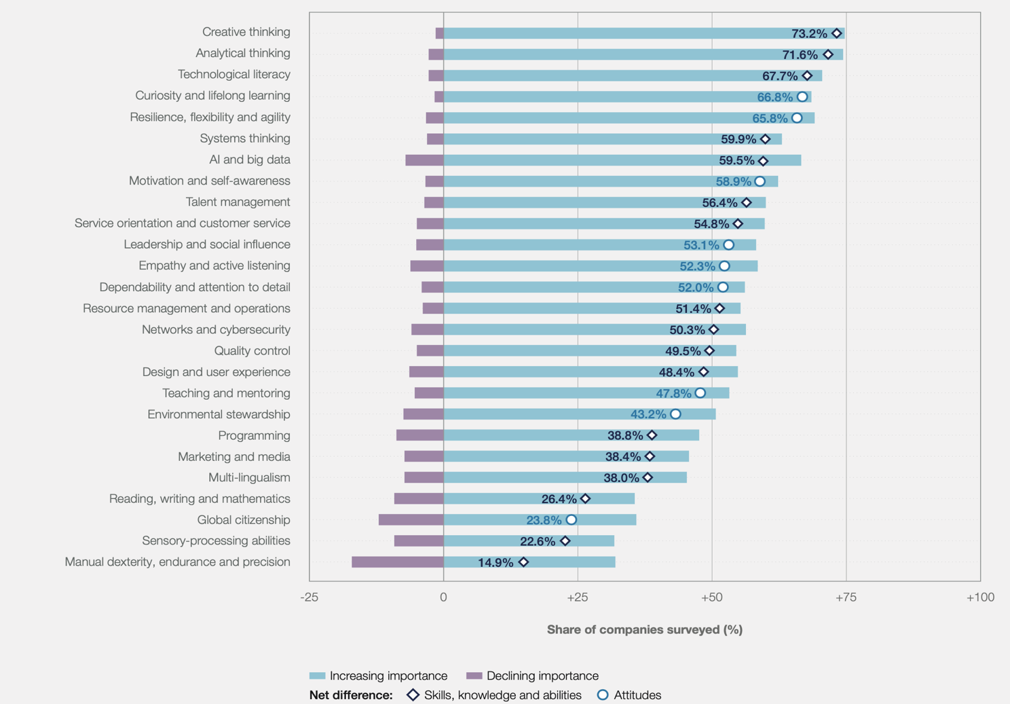

Expected changes in business skills over the next five years (2023-2027). Source: World Economic Forum, Future of Jobs Survey 2023.
Regarding Egypt, in the World Economic Forum's Future of Jobs Report 2023
"Analytical thinking, creative thinking, marketing and media, artificial intelligence, and big data are the most prioritized skills for retraining and development. The expected stability rate for the currently in-demand skills is 55% (compared to the global average of 50%). Regarding job changes, growth will occur in the following occupations: business development specialists (23%), mechanics and machine repair technicians (13%), general managers and operations managers (11%).

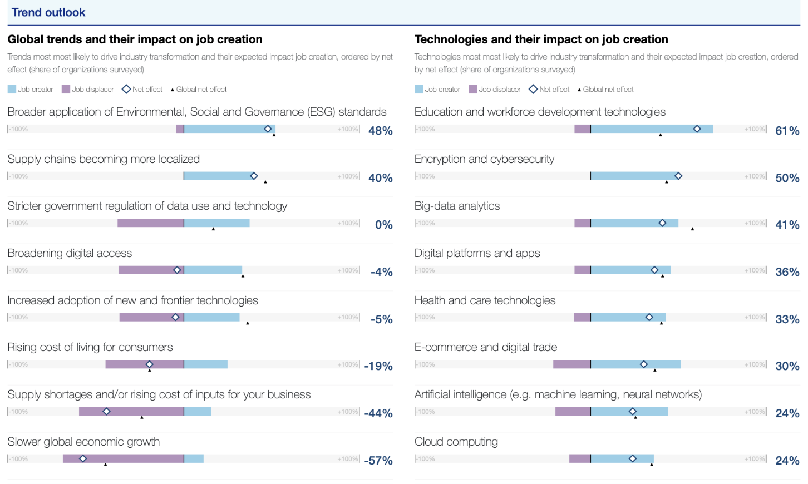
Trend Outlook:
Source: Future of Job Report 2023, World Economic Forum

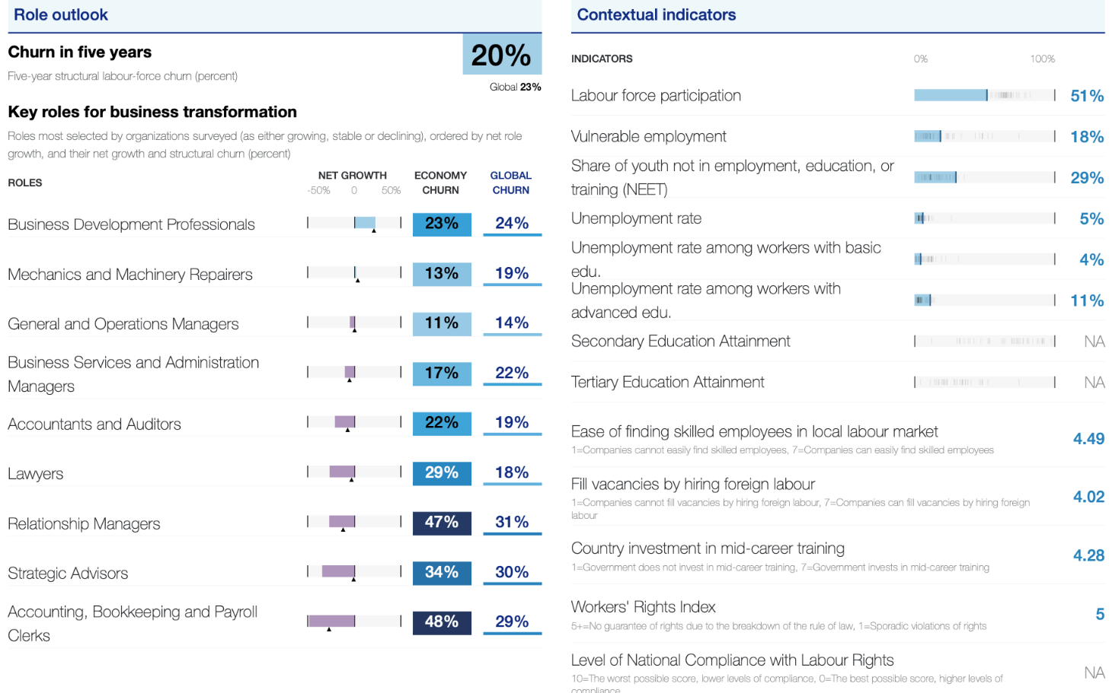
Role Outlook
Source: Future of Job Report 2023, World Economic Forum

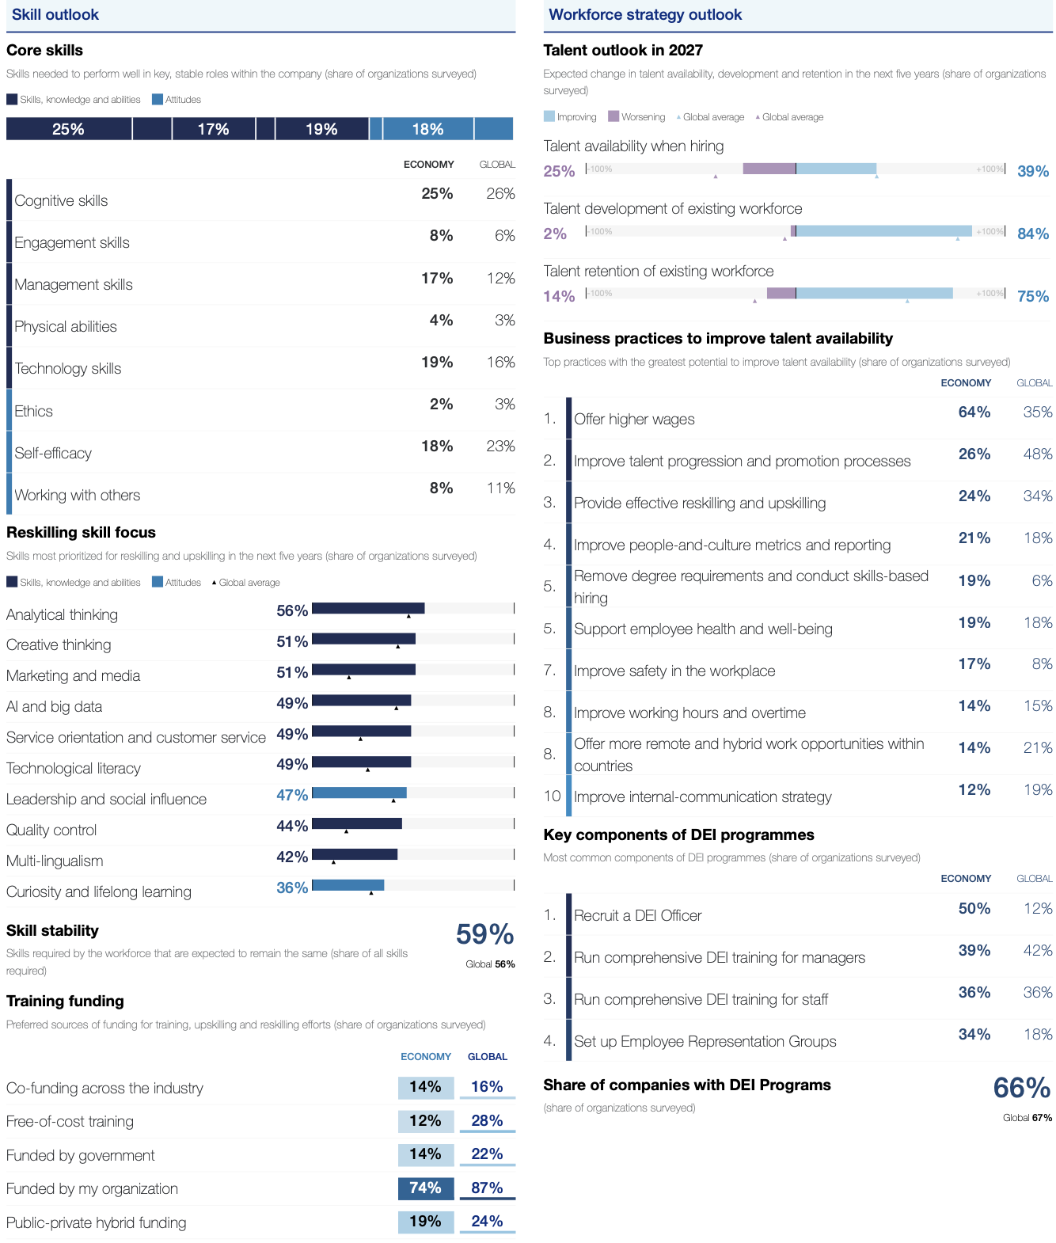
Skill Outlook
Source: Future of Job Report 2023, World Economic Forum

Annex (6)
The cumulative GPA for students transferred to a program operating on a credit-hour system is calculated based solely on the courses the student has taken under that program. Courses taken in any other credit-hour program or two-semester program at their own university or any other university are not considered. In all cases, credits are offset against the student's coursework to be included in the degree requirements but not included in the student's cumulative GPA.

Equivalent grades when transferring from the semester system to the credit hour system
From the Semester System | To the Credit Hour System
Grade Percentage | Number of Points | Grade
More than 95% | 4.0 | A+
90% to less than 95% | 4.0 | A
85% to less than 90% | 3.7 | A-
80% to less than 85% | 3.3 | B+
75% to less than 80% | 3.0 | B
71% to less than 75% | 2.7 | B-
68% to less than 71% | 2.3 | C+
65% to less than 68% | 2.0 | C
60% to less than 65% | 1.7 | C-
55% to less than 60% | 1.3 | D+
50% to less than 55% | 1.0 | D
Less than 50% | 0.0 | F

Annex (7)
Academic Record Statement Form (Transcript)

In this heading the type of academic degree (Bachelor of ------- - Record of Achievement) is identified.

This section describes the academic degree awarded.
Information Identifying the Holder of the Qualification | Basic Information for the Certificate Holder
Name:  Date of Birth:  Nationality: | National ID  Student ID
Information Identifying the Qualification | Academic Qualification Information
Qualification:  Program of Study: | Language of Teaching:  Awarding Institution:
Information Identifying the Holder General Grade | Overall Grade Data
Cumulative GPA:  Achieved Cumulative Credit Hours: | Overall Ranking:  Total Cumulative Credit Hours:
Information on the contents and results gained

Please refer to courses and grades in the next section | Info on content and results
Completed Course Details

Semester Completed | Course Code | Course Name | Credit | Grade | Credit Points | Repeated | Improved
Fall 2014 | Course Code | Course Name | 3 | B+ | 9.9 | -
Fall 2014 | Course Code | Course Name | 4 | A+ | 16 | -
Fall 2014 | Course Code | Course Name | 3 | B+ | 9.9 | -
Fall 2014 | Course Code | Course Name | 3 | A | 12 | -
Fall 2014 | Course Code | Course Name | 3 | B+ | 9.9 | -

Information identifying the student progress (Student progress data)
 | 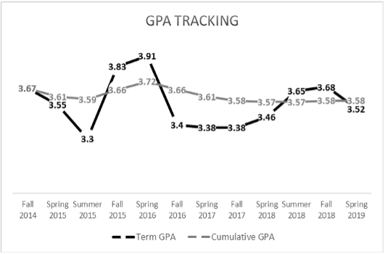
  Term | Term GPA | Cumulative GPA
  Fall 2014 | 3.67 | 3.67
  Spring 2015 | 3.55 | 3.61
  Summer 2015 | 3.3 | 3.59
  Fall 2015 | 3.83 | 3.66
  Spring 2016 | 3.91 | 3.72
  Fall 2016 | 3.4 | 3.66
  Spring 2017 | 3.38 | 3.61
  Fall 2017 | 3.38 | 3.58
  Spring 2018 | 3.46 | 3.57
  Summer 2018 | 3.65 | 3.57
  Fall 2018 | 3.68 | 3.58
  Spring 2019 | 3.52 | 3.58
Guided sample for a graph showing student progress

Courses distribution among departments | Percentages of courses and their relationship to departments (related majors)
 | 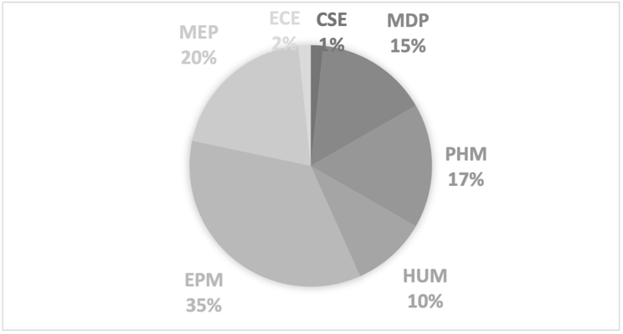
  Courses | Department
  CSE | 1
  MDP | 9
  PHM | 10
  HUM | 6
  EPM | 21
  MEP | 12
  ECE | 1

Date of Award Board: -----------------
Date of Issue: -----------------------------

Information on the level of qualification

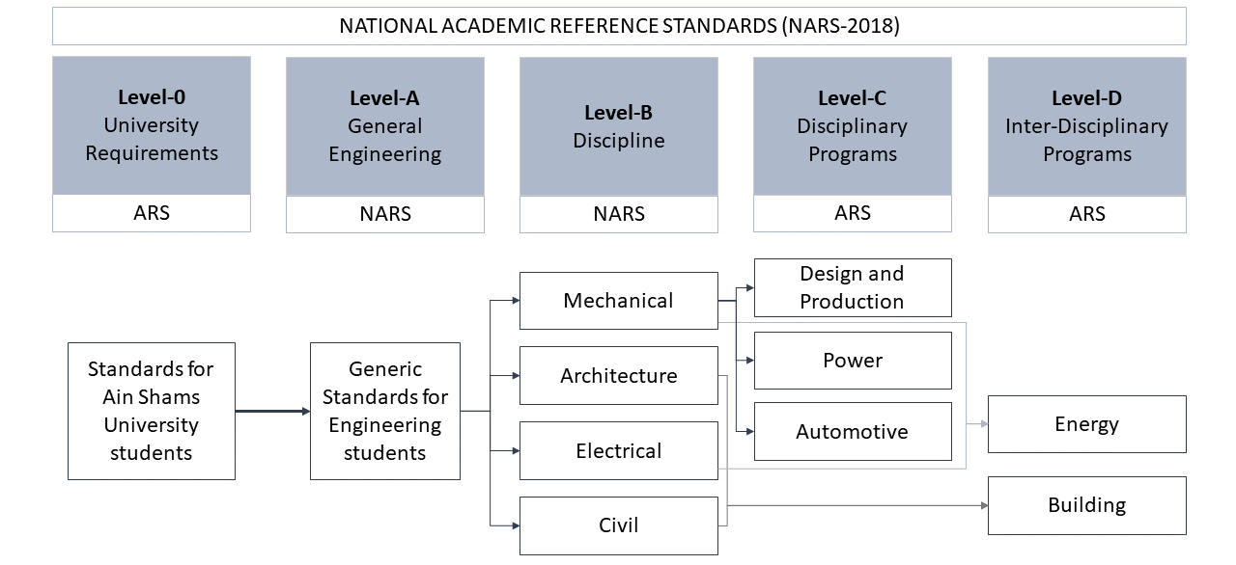

Guided sample for the level of qualification information

Minors
This section describes the minors and lists the courses.

Practical field training
This section lists the training completed by the student during the study period, along with the duration of each training session, so that the total number of training weeks/hours required for graduation is met, as determined by the educational institution.

International Publication
This section lists research papers published internationally.

Activities and Community Service
This section lists the activities the students participated in during the study period, their role in them, as well as the date and time period.

List of Abbreviations
Field | # | Discipline | Acronym
Field 1 | 1 | -------- | --------
Field 2 | 2 | -------- | --------
 | 3 | -------- | --------
 | 4 | -------- | --------
 | 5 | -------- | --------

Grade Classification
The GPA for each course is calculated based on the marks a student collects during their study of that course (Student Activities – Mid-Term Exam – Practical Exam – Final Exam). The following table shows how to calculate the GPA based on the collected marks. The student must get a minimum Grade D to pass the course and be considered in the calculation of the Cumulative GPA.

Percentage achieved | Grade | Points
More than 97% | A+ | 4
93% to less than 97% | A | 4
89% to less than 93% | A- | 3.7
84% to less than 89% | B+ | 3.3
80% to less than 84% | B | 3
76% to less than 80% | B- | 2.7
73% to less than 76% | C+ | 2.3
70% to less than 73% | C | 2
67% to less than 70% | C- | 1.7
64% to less than 67% | D+ | 1.3
60% to less than 64% | D | 1
Less than 60% | F | 0

Declaration of Honor:
This section specifies the requirements for obtaining an honors degree as determined by the educational institution.
    - ..........
    - ..........
Enrolment requirements (as established by applicable laws and regulations)
    - ..........
    - ..........
Program study duration
- ..........
- ..........
Degree awarding requirements
- ..........
- ..........

Annex (8)
New Academic Program Proposal Template
Required documents to be submitted:
- This Completed Proposal Template
- Proposed Program Curriculum
General Program Information
Program Name
Degree Level
Interdisciplinary program  (if yes, specify disciplines) | Yes ☐ No ☐
Interdisciplinary program  (if yes, specify disciplines) | Disciplines:
Faculty/ Faculties
Academic Department (S)
Program Type (collaborative, joint, or single institution):
Number of Credit Hours required
Method of Delivery (online/ face-to-face/ hybrid)
Institutional Board Approval Date
- Overview
- Provide a brief description of the program with its estimated date of implementation.
(250 words or less; program’s purpose/focus, primary areas of study, intended audience, academic level—undergraduate, graduate, or professional, length of the program, goals/objectives, rationale for program, skills or knowledge that students will acquire, relationship of program to general field).

- Describe how the new program is consistent with the mission and goals of the institution. (Provide a matrix showing relation among program aims and those of the institution).

- Describe the rationale of the program and specify related (international/regional/national) benchmarking, employability and possible jobs according to market study.
- Program Quality and Student Success
The curriculum should be structured to meet the stated objectives and student learning outcomes of the program.
- Provide program aims (objectives) and specific learning outcomes.

- Specify the program's competitive advantages.
Highlight the program's distinctive features and underscore its competitive advantages. This may include renowned faculty members with national or international recognition, seamless integration with a well-established program at your institution on local, national, or global levels, or any unique elements that distinguish the program within its field.

- Describe the admission and graduation requirements for the program.
Be as detailed as possible and address all three components – admission, retention, and completion.

- Provide the following information for the program and for each track, concentration, or specialization (some categories may not apply to all programs).
A guided elective is any elective that is part of a major. A free elective is an elective from any academic area not required for a major or minor.
Program/Track, Concentration, or Specialization | Total number of hours required for degree | Number of hours in degree program core | Number of hours in track | Number of hours in guided electives | Number of hours in free electives

- Will this program replace or enhance any existing program(s) or tracks, concentrations, or specializations within an existing program? If yes, please explain. Yes ☐ No ☐

- How will the program support or be supported by other programs and/or units within the institution? Please also describe potential for collaboration with other programs within the institution.
- Feasibility
To evaluate program feasibility, we need details on resource needs and funding sources. This ensures efficient resource utilization and assesses the program's impact on overall institutional funding.
- Provide estimated student enrollment for the (five) years of the program showing evidence.
Academic Year | Student Number

- Will this program require additional resources or/and impact existing programs and/or organizational units within your institution? If yes, please explain. Yes ☐ No ☐
If so, please provide a brief summary of new or additional resources that will be needed to implement this program over the next five years.

Interactive learning is the process of entry and exit of a learning activity to support individual students’ needs and enhance their increased independence. It also involves benefiting from student interactions, promoting flexibility, determining clear-cut educational objectives and advancing teacher-student exchange of ideas. https://journals.sagepub.com/doi/pdf/10.1207/s15548430jlr3704_3
The concept of student chapter in higher education means forming groups or associations organized by students who have common academic interests, objectives or affiliations. These chapters offer students a portal for cooperation, knowledge-sharing and participation in activities relevant to their studies. Customarily, these classes provide a supportive society for communication, development of professional skills, and exchange of ideas between students who share similar academic or career aspirations regionally or internationally.
https://neet.mit.edu/threads

